George H. W. Bush

**From Wikipedia, the free encyclopedia**

https://en.wikipedia.org/wiki/George%20H.%20W.%20Bush  
Licensed under CC BY-SA 3.0:  
https://en.wikipedia.org/wiki/Wikipedia:Text_of_Creative_Commons_Attribution-ShareAlike_3.0_Unported_License

# George H. W. Bush

* *Until his son George W. Bush became the 43rd president in 2001, he was usually known simply as George Bush.*
* *With George W. Bush's victory in the 2000 presidential election, Bush and his son became the second father–son pair to serve as president, following John Adams and John Quincy Adams.*
* *Bush ran for president in 1980, was defeated in the Republican primary by Ronald Reagan, and then as Reagan's running mate Bush became vice-president after the ticket's election.*

George Herbert Walker Bush (June 12, 1924 – November 30, 2018) was an American politician who served as the 41st president of the United States from 1989 to 1993 and the 43rd vice president from 1981 to 1989. A member of the Republican Party, he held posts that included those of congressman, ambassador, and CIA director. Until his son George W. Bush became the 43rd president in 2001, he was usually known simply as George Bush.

Bush postponed his university studies after the attack on Pearl Harbor on December 7, 1941, enlisted in the Navy on his 18th birthday, and became one of its youngest aviators. He served until September 1945, and then attended Yale University, graduating in 1948. He moved his family to West Texas where he entered the oil business and became a millionaire by the age of 40 in 1964. After founding his own oil company, Bush was defeated in his first run for the United States Senate in 1964, but won election to the House of Representatives from Texas's 7th congressional district in 1966. He was reelected in 1968 but was defeated for election to the Senate in 1970. In 1971, President Richard Nixon appointed Bush as Ambassador to the United Nations, and he became Chairman of the Republican National Committee in 1973. The following year, President Gerald Ford appointed him Chief of the Liaison Office in China and later made him the director of Central Intelligence. Bush ran for president in 1980, was defeated in the Republican primary by Ronald Reagan, and then as Reagan's running mate Bush became vice-president after the ticket's election. During his eight-year tenure as vice president, Bush headed task forces on deregulation and the war on drugs.

Bush in 1988 defeated Democratic opponent Michael Dukakis, becoming the first incumbent vice president to be elected president in 152 years. Foreign policy drove the Bush presidency; military operations were conducted in Panama and the Persian Gulf, the Berlin Wall fell in 1989, and the Soviet Union dissolved two years later. Bush also signed the North American Free Trade Agreement (NAFTA), which created a trade bloc consisting of the United States, Canada, and Mexico. Domestically, Bush reneged on a 1988 campaign promise and signed a bill to increase taxes. He lost the 1992 presidential election to Democrat Bill Clinton following an economic recession and the decreased importance of foreign policy in a post–Cold War political climate.

After leaving office in 1993, Bush was active in humanitarian activities, often alongside Clinton, his former opponent. With George W. Bush's victory in the 2000 presidential election, Bush and his son became the second father–son pair to serve as president, following John Adams and John Quincy Adams. At the time of his death, he was the longest-lived president in U.S. history, a record surpassed by Jimmy Carter on March 22, 2019.

# Early life and education

* *Bush was named after his maternal grandfather George Herbert Walker, who was known as "Pop", and young Bush was called "Poppy" as a tribute to his namesake.*
* *George Herbert Walker Bush was born at 173 Adams Street in Milton, Massachusetts on June 12, 1924 to Prescott Sheldon Bush and Dorothy (Walker) Bush.*

George Herbert Walker Bush was born at 173 Adams Street in Milton, Massachusetts on June 12, 1924 to Prescott Sheldon Bush and Dorothy (Walker) Bush. The Bush family moved from Milton to Greenwich, Connecticut shortly after his birth. Bush was named after his maternal grandfather George Herbert Walker, who was known as "Pop", and young Bush was called "Poppy" as a tribute to his namesake.

Bush began his formal education at the Greenwich Country Day School, then attended Phillips Academy in Andover, Massachusetts beginning in 1938, where he held a number of leadership positions which included president of the senior class, secretary of the student council, president of the community fund-raising group, a member of the editorial board of the school newspaper, and captain of the varsity baseball and soccer teams.

  
*Crewmen of the submarine USS Finback rescue Bush*

# World War II

* *His aircraft was hit by flak during the attack, but Bush successfully released bombs and scored several hits.*
* *In November 1944, Bush returned to San Jacinto and participated in operations in the Philippines until his squadron was replaced and sent home to the United States.*
* *This experience shaped Bush profoundly, leading him to ask, "Why had I been spared and what did God have for me?"*

Six months after the United States entered World War II following Japan's attack on Pearl Harbor, Bush enlisted in the U.S. Navy immediately after he graduated from Phillips Academy on his 18th birthday. He became a naval aviator, taking training for aircraft carrier operations aboard USS Sable. After completing the 10-month course, he was commissioned as an ensign in the Naval Reserve at Naval Air Station Corpus Christi on June 9, 1943, just three days before his 19th birthday, which made him one of the youngest aviators in the Navy.

In September 1943, he was assigned to Torpedo Squadron 51 (VT-51) as the photographic officer. The following year, his squadron was assigned to the USS San Jacinto as a member of Air Group 51, where his lanky physique earned him the nickname "Skin". During this time, the task force was victorious at the Battle of the Philippine Sea, one of the largest air battles of World War II.

Bush was promoted to lieutenant (junior grade) on August 1, 1944, and San Jacinto commenced operations against the Japanese in the Bonin Islands. He piloted one of the four Grumman TBM Avengers of VT-51 that attacked the Japanese installations on Chichijima on September 2, 1944. His crew included Radioman Second Class John Delaney and Lt.(jg) William White. His aircraft was hit by flak during the attack, but Bush successfully released bombs and scored several hits. With his engine ablaze, he flew several miles from the island, where he and one other crew member bailed out; the other man's parachute did not open. Bush spent four hours in his inflated liferaft, protected by fighter aircraft circling above, until the submarine USS Finback came to his rescue. He remained in Finback for the next month and participated in the rescue of other aviators. Several of those shot down during the attack were executed, and their livers were eaten by their captors. This experience shaped Bush profoundly, leading him to ask, "Why had I been spared and what did God have for me?"

In November 1944, Bush returned to San Jacinto and participated in operations in the Philippines until his squadron was replaced and sent home to the United States. By 1944 he had flown 58 combat missions for which he received the Distinguished Flying Cross, three Air Medals, and the Presidential Unit Citation awarded to San Jacinto. He was then reassigned to a training wing for torpedo bomber crews at Norfolk Navy Base, Virginia. His final assignment was to the new torpedo squadron VT-153 based at Naval Air Station Grosse Ile, Michigan. He was honorably discharged from the Navy in September 1945, one month after the surrender of Japan.

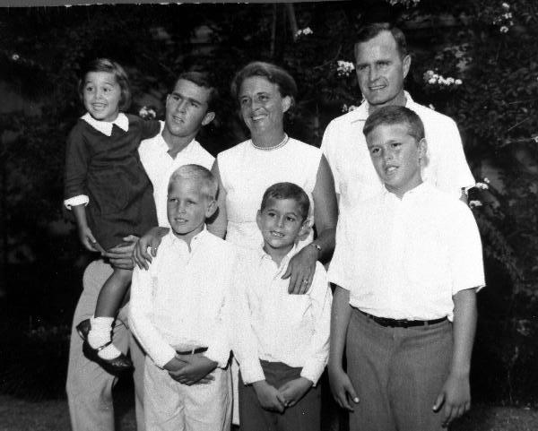  
*Bush, top right, surrounded by his family, mid 1960s*

# Marriage and college years

* *Late in his junior year, he was initiated into the Skull and Bones secret society; his father Prescott Bush had been initiated into the same society in 1917.*
* *After Bush received his military discharge, he enrolled at Yale University.*
* *When Bush was still in the Navy, he married Barbara Pierce (1925–2018) in Rye, New York, on January 6, 1945.*

When Bush was still in the Navy, he married Barbara Pierce (1925–2018) in Rye, New York, on January 6, 1945. The marriage produced six children: George W. (b. 1946), Robin (1949–1953), Jeb (b. 1953), Neil (b. 1955), Marvin (b. 1956), and Doro (b. 1959). At the time of his wife's death on April 17, 2018, George H. W. had been married to Barbara for 73 years; theirs was the longest presidential marriage in American history. They had become the longest-married presidential couple in 2000 when their marriage surpassed the 54-year (1764–1818) marriage of John and Abigail Adams.

After Bush received his military discharge, he enrolled at Yale University. He earned an undergraduate degree in economics on an accelerated program that enabled him to graduate in two and a half years, rather than the usual four. He was a member of the Delta Kappa Epsilon fraternity and was elected its president. He also captained the Yale baseball team and played in the first two College World Series as a left-handed first baseman. Bush was the team captain during his senior year in 1948, and he met Babe Ruth before a game; the event took place only weeks before Ruth's death. Like his father, he was also a member of the Yale cheerleading squad. Late in his junior year, he was initiated into the Skull and Bones secret society; his father Prescott Bush had been initiated into the same society in 1917. He was elected to Phi Beta Kappa when he graduated from Yale in 1948 with a Bachelor of Arts degree in economics.

# Business career

* *According to eldest son George W. Bush, then age two, the family lived in one of the few duplexes in Odessa with an indoor bathroom, which they "shared with a couple of hookers".*
* *After graduating from Yale, Bush moved his young family to West Texas.*
* *By that time, Bush had become a millionaire.*
* *Bush continued serving as president of the company until 1964, and later chairman until 1966, when he won election to the U.S. House of Representatives.*

After graduating from Yale, Bush moved his young family to West Texas. His father's business connections proved useful as he ventured into the oil business, starting as an oil field equipment salesman for Dresser Industries, a subsidiary of Brown Brothers Harriman & Co., where Prescott Bush had served on the board of directors for 22 years. While working for Dresser, Bush lived in various places with his family: Odessa, Texas; Ventura, Bakersfield and Compton, California; and Midland, Texas. According to eldest son George W. Bush, then age two, the family lived in one of the few duplexes in Odessa with an indoor bathroom, which they "shared with a couple of hookers". Bush started the Bush-Overbey Oil Development company in 1951 and in 1953 co-founded the Zapata Petroleum Corporation, an oil company that drilled in the Permian Basin in Texas. In 1954, he was named president of the Zapata Offshore Company, a subsidiary which specialized in offshore drilling. Shortly after the subsidiary became independent in 1959, Bush moved the company and his family from Midland to Houston.

Beginning in 1960 or 1961, Bush was a clandestine employee or agent of the United States Central Intelligence Agency using as cover his work in the petroleum production business. In that role, he appears to have been associated with CIA-affiliated anti-Castro Cubans who had been involved in the failed Bay of Pigs Invasion. When confronted with a 1963 Federal Bureau of Investigation memorandum evidencing his being a CIA operative, Bush issued a non-denial denial.

Bush continued serving as president of the company until 1964, and later chairman until 1966, when he won election to the U.S. House of Representatives. By that time, Bush had become a millionaire.

# Early political career

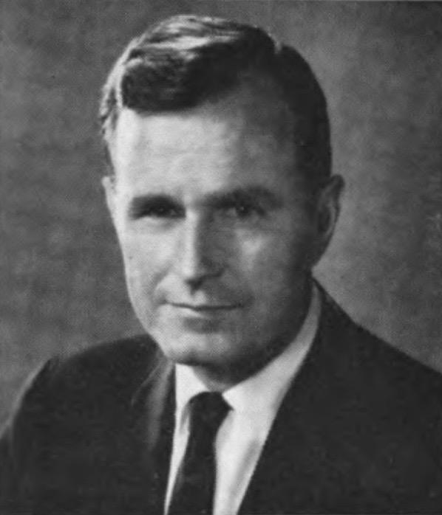  
*Bush in 1969*

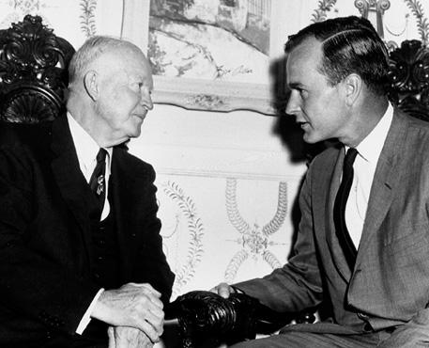  
*Former president Dwight D. Eisenhower with Bush*

# Congressional years (1967–1971)

* *Bush worked to absorb the John Birch Society members, who were trying to take over the Party.*
* *Bush and the Harris County Republicans played a role in the development of the new Republican Party of the late 20th century.*
* *Yarborough endorsed Bentsen, who went on to defeat Bush, 53.4 to 46.6%.*
* *Bush was the first House Republican to represent his Houston district, which included his residence in the Tanglewood area.*

Bush's career in politics began on February 20, 1963 when he was elected chairman of the Harris County, Texas Republican Party. The following year, he ran against incumbent Democrat Ralph W. Yarborough in the U.S. Senate race. He was a young Conservative Republican in contrast to the aging liberal Democrat Yarborough, and campaigned against pending civil rights legislation, believing it gave too much power to the federal government. Bush lost the election 56% to 44%, though he did outpoll Republican presidential nominee Barry Goldwater, who lost by an overwhelming margin to Lyndon B. Johnson.

Bush and the Harris County Republicans played a role in the development of the new Republican Party of the late 20th century. Bush worked to absorb the John Birch Society members, who were trying to take over the Party. Also, as a result of the civil rights movement, Democrats in the South who were committed to segregation left their party, and though these "country club Republicans" had differing ideological beliefs, they found common ground in hoping to expel the Democrats from power.

In 1966, Bush was elected to a seat in the United States House of Representatives from the 7th District of Texas; he won 57 percent of the ballots cast in a race against Democrat Frank Briscoe, the district attorney of Harris County. Bush was the first House Republican to represent his Houston district, which included his residence in the Tanglewood area. His voting record in the House was generally conservative: Bush voted for the Civil Rights Act of 1968, although it was generally unpopular in his district. He supported the Nixon administration's Vietnam policies, but broke with Republicans on the issue of birth control, which he supported. Despite being a first-term congressman, Bush was appointed to the powerful United States House Committee on Ways and Means, where he voted to abolish the military draft. He was elected to a second term in 1968.

In 1970, Nixon convinced Bush to relinquish his House seat in order to run for the Senate against Ralph Yarborough, who was a fierce Nixon critic. In the Republican primary, Bush easily defeated conservative Robert J. Morris by a margin of 87.6% to 12.4%. Nixon went to Longview, Texas, to campaign for Bush and gubernatorial candidate Paul Eggers, a Dallas lawyer who was a close friend of U.S. Senator John G. Tower. Former Congressman Lloyd Bentsen, a more moderate Democrat and native of Mission in south Texas, defeated Yarborough in the Democratic primary. Yarborough endorsed Bentsen, who went on to defeat Bush, 53.4 to 46.6%.

  
*Bush as ambassador to the United Nations, 1971*

# Ambassador to the United Nations (1971–1973)

* *Although Bush condemned the "gladiatorial ugliness" of the debate, he advocated friendly relations with the Chinese delegation.*
* *Nixon appreciated the sacrifice Bush had made of his Congressional position and nominated him United States Ambassador to the United Nations.*
* *Following his 1970 loss, Bush was well known as a prominent Republican businessman from the southern Sun Belt.*

Following his 1970 loss, Bush was well known as a prominent Republican businessman from the southern Sun Belt. Nixon appreciated the sacrifice Bush had made of his Congressional position and nominated him United States Ambassador to the United Nations. He was confirmed unanimously by the Senate in 1971 and served for two years.

His ambassadorship was marked by a defeat on the China question. On October 25, 1971, the General Assembly voted to expel the Republic of China and replace it with the People's Republic of China. Many delegates hissed at Bush when he got up to speak, and then cheered and danced after defeating his motion to require a two-thirds supermajority. The resolution then won a two-thirds supermajority anyway, as the United States lost the support of every NATO country. Although Bush condemned the "gladiatorial ugliness" of the debate, he advocated friendly relations with the Chinese delegation. Two months later, Bush even placed himself in the position of depending on a Chinese veto in the 1971 Secretary-General selection. However he did not tell the Chinese, who unexpectedly abstained and allowed Kurt Waldheim to be selected as the next Secretary-General of the United Nations.

# Chairman of the Republican National Committee (1973–1974)

* *As chairman, Bush formally requested that Nixon eventually resign for the good of the party.*
* *Bush took over in January 1973 and held this position as the Watergate scandal grew more damaging to Nixon.*
* *After Bob Dole resigned as chairman of the Republican National Committee in 1972, Nixon named Bush to the position.*

After Bob Dole resigned as chairman of the Republican National Committee in 1972, Nixon named Bush to the position. Bush took over in January 1973 and held this position as the Watergate scandal grew more damaging to Nixon. He initially defended Nixon steadfastly, but as Nixon's complicity became clear he focused more on defending the Republican Party. As chairman, Bush formally requested that Nixon eventually resign for the good of the party. When Nixon did this on August 9, 1974, Bush noted in his diary that "There was an aura of sadness, like somebody died... The [resignation] speech was vintage Nixon—a kick or two at the press—enormous strains. One couldn't help but look at the family and the whole thing and think of his accomplishments and then think of the shame... [President Gerald Ford's swearing-in offered] indeed a new spirit, a new lift."

  
*Bush as U.S. Liaison to China, circa 1975*

# Head of U.S. Liaison Office in China (1974–1975)

* *After Ford assumed the presidency, Bush was under serious consideration for being nominated as vice president.*
* *Ford eventually narrowed his list to Nelson Rockefeller and Bush.*
* *Ford again passed over Bush when he chose Bob Dole to replace Rockefeller on the 1976 presidential ticket.*
* *President Gerald Ford appointed Bush to be Chief of the U.S. Liaison Office in the People's Republic of China.*

President Gerald Ford appointed Bush to be Chief of the U.S. Liaison Office in the People's Republic of China. Since the United States maintained diplomatic relations with the Republic of China (Taiwan) instead of the People's Republic of China, Bush did not hold the diplomatic rank of ambassador. However, Bush performed as an ambassador, ignoring instructions from Henry Kissinger to stay away from diplomatic functions. The 14 months that he spent in China were seen as beneficial for China–United States relations.

After Ford assumed the presidency, Bush was under serious consideration for being nominated as vice president. Ford eventually narrowed his list to Nelson Rockefeller and Bush. White House Chief of Staff Donald Rumsfeld reportedly preferred Rockefeller over Bush. Rockefeller was finally named and confirmed. Ford again passed over Bush when he chose Bob Dole to replace Rockefeller on the 1976 presidential ticket.

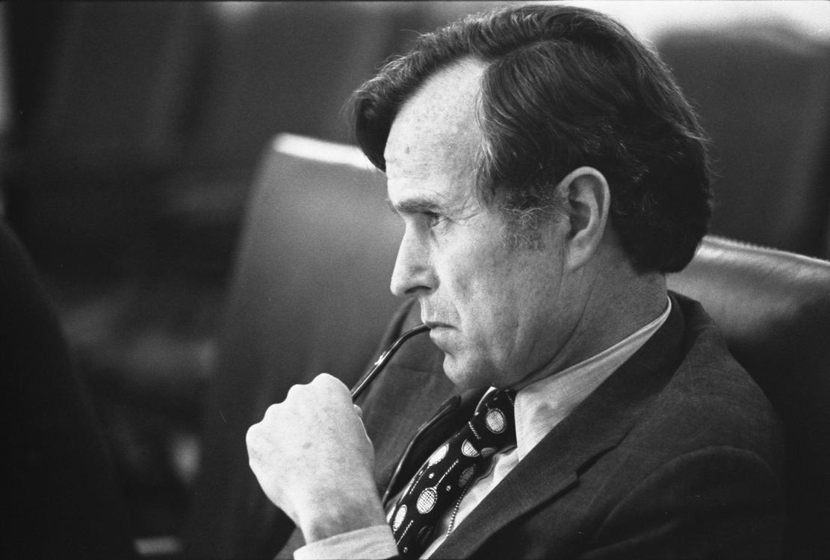  
*Bush, as CIA Director, listens at a meeting following the assassinations in Beirut of Francis E. Meloy Jr. and Robert O. Waring, 1976.*

# Director of Central Intelligence (1976–1977)

* *In 1999, the CIA headquarters in Langley, Virginia, was named George Bush Center for Intelligence in his honor.*
* *In his capacity as DCI, Bush gave national security briefings to Jimmy Carter both as a presidential candidate and as president-elect, and discussed the possibility of remaining in that position in a Carter administration, but did not do so.*
* *In 1976 Ford brought Bush back to Washington to become Director of Central Intelligence (DCI), replacing William Colby.*

In 1976 Ford brought Bush back to Washington to become Director of Central Intelligence (DCI), replacing William Colby. He served in this role for 357 days, from January 30, 1976, to January 20, 1977. The Central Intelligence Agency (CIA) had been rocked by a series of revelations, including those based on investigations by the Church Committee regarding illegal and unauthorized activities by the CIA, and Bush was credited with helping to restore the agency's morale. In his capacity as DCI, Bush gave national security briefings to Jimmy Carter both as a presidential candidate and as president-elect, and discussed the possibility of remaining in that position in a Carter administration, but did not do so. He was succeeded by Deputy Director of Central Intelligence E. Henry Knoche, who served as acting Director of Central Intelligence until Stansfield Turner was confirmed.

During Bush's year in charge of the CIA, the U.S. national security apparatus actively supported Operation Condor operations and right-wing military dictatorships in Latin America.

In 1999, the CIA headquarters in Langley, Virginia, was named George Bush Center for Intelligence in his honor.

# Other positions (1977–1981)

* *He later spent a year as a part-time professor of Administrative Science at Rice University's Jones School of Business beginning in 1978, the year it opened; Bush said of his time there, "I loved my brief time in the world of academia."*
* *After Democrat Jimmy Carter took power in 1977, Bush became chairman on the Executive Committee of the First International Bank in Houston.*

After Democrat Jimmy Carter took power in 1977, Bush became chairman on the Executive Committee of the First International Bank in Houston. He later spent a year as a part-time professor of Administrative Science at Rice University's Jones School of Business beginning in 1978, the year it opened; Bush said of his time there, "I loved my brief time in the world of academia." Between 1977 and 1979, he was a director of the Council on Foreign Relations foreign policy organization.

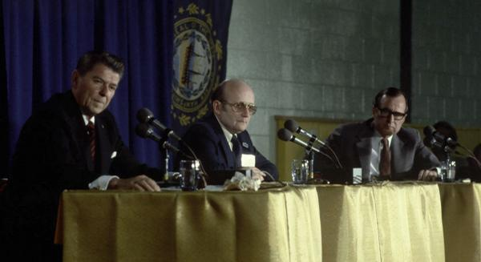  
*Ronald Reagan, moderator John Breen, and Bush participate in the Nashua, New Hampshire Presidential Debate, 1980*

# 1980 presidential campaign

* *Reagan invited the other four candidates as well, but Bush refused to debate them, and eventually they left.*
* *Bush ended up losing New Hampshire's primary with 23% to Reagan's 50%.*
* *Bush represented the centrist wing in the GOP, whereas Reagan represented conservatives.*
* *After the win, Bush stated that his campaign was full of momentum, or "the Big Mo".*

Bush decided in the late 1970s that he was going to run for president in 1980; in 1979, he attended 850 political events ("cattle calls") and traveled more than 250,000 miles (400,000 km) to campaign for the nation's highest office. In the contest for the Republican Party nomination, Bush stressed his wide range of government experience, while competing against rivals Senator Howard Baker of Tennessee, Senator Bob Dole of Kansas, Congressman John Anderson of Illinois (who would later run as an independent), Congressman Phil Crane, also of Illinois, former Governor John Connally of Texas, former Minnesota Governor Harold Stassen, and the front-runner Ronald Reagan, a noted former actor and the former Governor of California.

At the outset of the 1980 primary race, Bush focused heavily on winning the January 21 Iowa caucuses, including 31 visits to the state; five months earlier he had won the Iowa Straw Poll. Reagan, however, far ahead in the polls, campaigned little. Bush represented the centrist wing in the GOP, whereas Reagan represented conservatives. Bush famously labeled Reagan's supply side-influenced plans for massive tax cuts "voodoo economics". His strategy proved useful, to some degree, as he won in Iowa with 31.5% to Reagan's 29.4%. After the win, Bush stated that his campaign was full of momentum, or "the Big Mo".

As a result of the loss, Reagan replaced his campaign manager, reorganized his staff, and concentrated on the New Hampshire primary. The two men agreed to a debate in the state, organized by The Nashua Telegraph, but paid for by the Reagan campaign. Reagan invited the other four candidates as well, but Bush refused to debate them, and eventually they left. The debate proved to be a pivotal moment in the campaign; when the moderator, John Breen, ordered Reagan's microphone turned off, his angry response, "I am paying for this microphone," struck a chord with the public. Bush ended up losing New Hampshire's primary with 23% to Reagan's 50%. Bush lost most of the remaining primaries as well, and formally dropped out of the race in May of that year.

With his political future in doubt, Bush sold his house in Houston and bought his grandfather's estate in Kennebunkport, Maine, known as "Walker's Point". At the Republican Convention, Reagan made the last-minute decision to select Bush as his vice presidential nominee, placing him on the winning Republican presidential ticket of 1980.

# Vice presidency

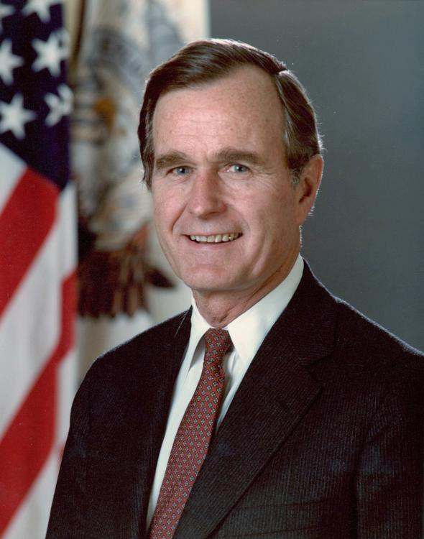  
*Vice President Bush, official portrait (1981)*

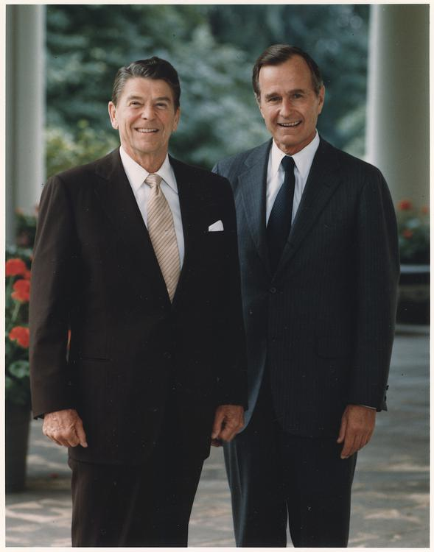  
*President Ronald Reagan with Bush*

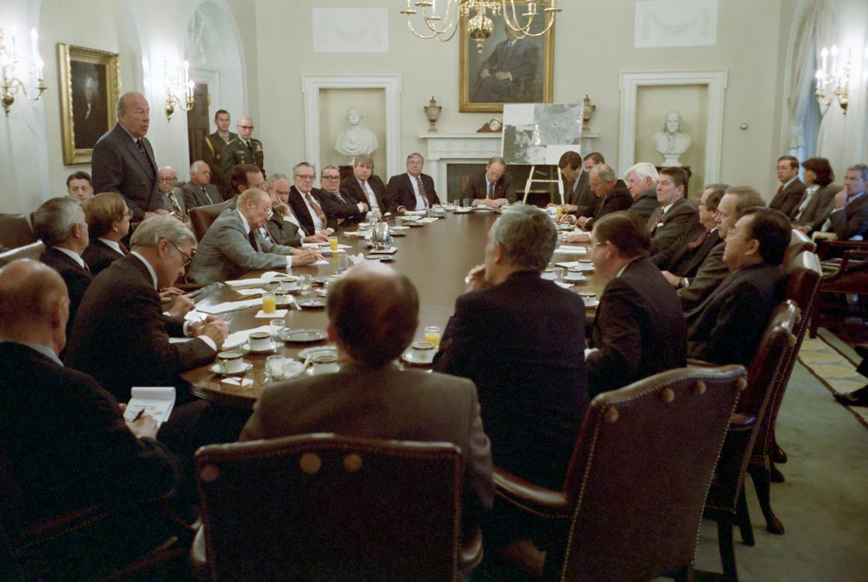  
*Reagan and Bush in a meeting to discuss the United States' invasion of Grenada with a group of bipartisan members of Congress in October 1983*

# First term (1981–1985)

* *Bush later said, "The meeting was frank, cordial and substantive.*
* *Bush rejected the idea, responding, "Only the president lands on the South Lawn."*
* *As the President of the Senate, Bush stayed in contact with members of Congress and kept the president informed on occurrences on Capitol Hill.*
* *Both were popular issues with conservatives, and Bush, largely a moderate, began courting them through his work.*

As vice president, Bush generally maintained a low profile, recognizing the constitutional limits of the office; he avoided decision-making or criticizing Reagan in any way. As had become customary, he and his wife moved into the vice president's residence at Number One Observatory Circle, about two miles from the White House. After selling their house in Tanglewood, the Bushes declared a room in The Houstonian Hotel in Houston as their official voting address. The Bushes attended a large number of public and ceremonial events in their positions, including many state funerals, which became a common joke for comedians. Mrs. Bush found the funerals largely beneficial, saying, "George met with many current or future heads of state at the funerals he attended, enabling him to forge personal relationships that were important to President Reagan." As the President of the Senate, Bush stayed in contact with members of Congress and kept the president informed on occurrences on Capitol Hill.

On March 30, 1981 (early into the administration), Reagan was shot and seriously wounded by John Hinckley Jr. in Washington, D.C. Bush was in Fort Worth, Texas, and immediately flew back to Washington D.C. because he was next in line to the presidency. Reagan's cabinet convened in the White House Situation Room, where they discussed various issues, including the availability of the "nuclear football". When Bush's plane landed, he was advised by his aides to proceed directly to the White House by helicopter as an image of the government still functioning despite the attack. Bush rejected the idea, responding, "Only the president lands on the South Lawn." This made a positive impression on Reagan, who recovered and returned to work within two weeks. From then on, the two men would have regular Thursday lunches in the Oval Office.

In November 1982, Bush toured Africa, the first instance of a high United States government official visiting the continent since the Reagan administration began. Bush told reporters that while he would allow for heads of state to dictate how each meeting would transpire, there was an expectation on his part for discussions on the independence of Namibia, adding that the United States was going to retain the position of no settlement in Namibia until Cuban troops in Angola were withdrawn. On November 15, Bush met with United States Secretary of State George P. Shultz and Yuri Andropov in Moscow, Russia, to discuss human rights and arms reductions. Bush later said, "The meeting was frank, cordial and substantive. It gave both sides the opportunity to exchange views on the state of their relations."

At the end of January 1983, Bush began a seven-day tour of Western Europe intended to promote the arms reduction commitment being advocated for by the Reagan administration. During a February 8 news conference in Paris, Bush said the United States' invitations for the Soviet Union to consent to a reduction in medium-range missiles were supported by Western Europe, which he stated had also consented to the deployment of new American missiles starting in the latter part of the year. The following day, Bush defended American nuclear arms policy when answering British Secretary General of the Committee on Nuclear Disarmament Bruce Kent.

In September 1983, Bush met with President of Romania Nicolae Ceaușescu, insisting during the meeting that President Reagan intended to push for arms reductions at the Geneva talks with the Soviet Union. Shortly thereafter, Bush said the United States wanted better relations with all countries within the Eastern Bloc, though he stressed that NATO would retaliate in the event of any threatening of European military stability by the Soviets, and he assailed the Soviet Union for the Berlin Wall and destroying the Korean Air Lines jetliner.

In December 1983 Bush flew to El Salvador and warned that country's military leaders to end their death squads and hold fully free elections or face the loss of U.S. aid. "It is not just the President, it is not just me or the Congress. If these death-squad murders continue, you will lose the support of the American people and that would indeed be a tragedy." Bush's aides feared for his safety and thought about calling the meeting off when they discovered apparent blood stains on the floor of the presidential palace of Álvaro Magaña. Bush was never told of the aides' concerns and a tense meeting was held in which some of Magaña's personnel brandished semiautomatic weapons and refused requests to take them outside.

On June 14, 1984, Bush cast a tie-breaking vote in the Senate in favor of the 10-warhead MX missile system.

Bush was assigned by Reagan to chair two special task forces, on deregulation and international drug smuggling. The deregulation task force reviewed hundreds of rules, making specific recommendations on which ones to amend or revise, in order to curb the size of the federal government. The drug smuggling task force coordinated federal efforts to reduce the quantity of drugs entering the United States. Both were popular issues with conservatives, and Bush, largely a moderate, began courting them through his work.

According to journalist Seymour Hersh, Bush set up a covert military team which bypassed the CIA and congressional oversight. The team was led by Vice-Admiral Arthur S. Moreau Jr. and carried out operations against terrorists, drug traffickers and Soviet spies.

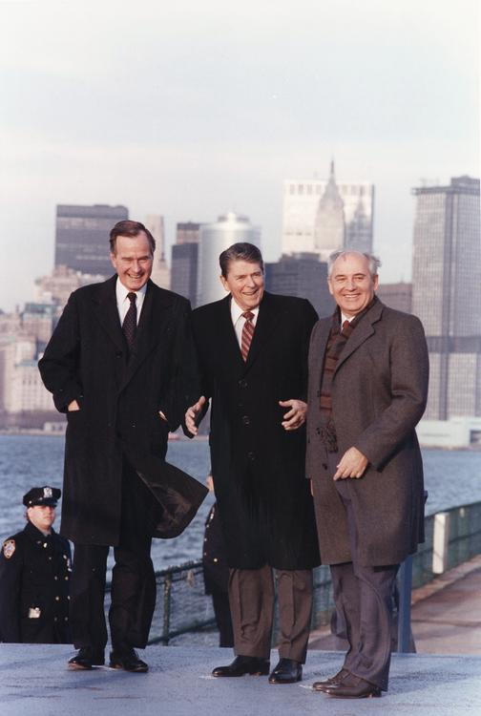  
*International policy with the Soviet Union was a critical component of the political landscape in the late 1980s. Vice President Bush can be seen here standing with President Ronald Reagan and Soviet leader Mikhail Gorbachev, on the New York City waterfront, 1988.*

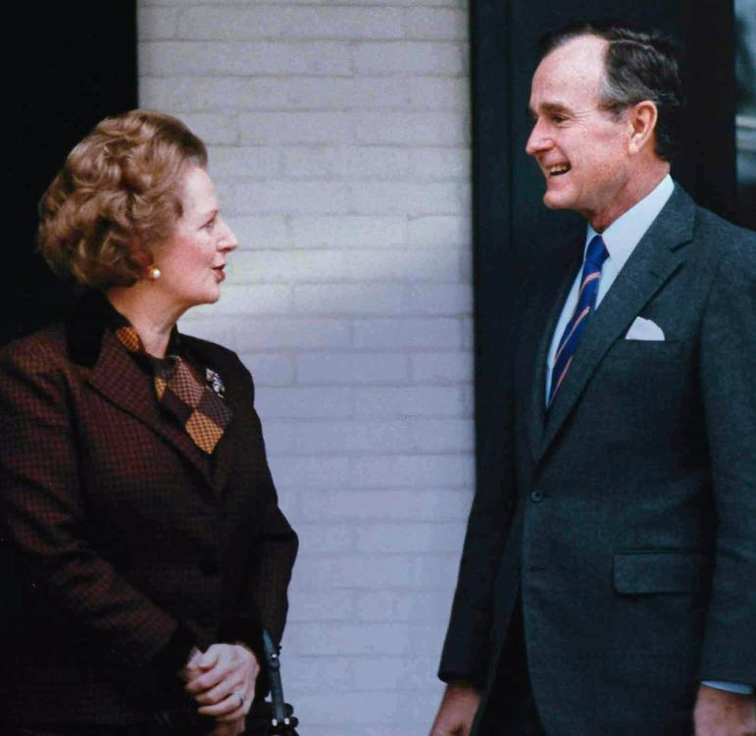  
*British Prime Minister Margaret Thatcher and Bush, 1986*

# Second term (1985–1989)

* *Bush said that he would "never apologize for the United States of America.*
* *Reagan and Bush ran for reelection in 1984.*
* *She and Bush squared off in a single televised vice presidential debate.*
* *On July 13, 1985, Bush became the first vice president to serve as acting president when Reagan underwent surgery to remove polyps from his colon; Bush served as the acting president for approximately eight hours.*

Reagan and Bush ran for reelection in 1984. Their Democratic opponent, Walter Mondale, made history by choosing a woman, New York Representative Geraldine Ferraro, as his running mate. She and Bush squared off in a single televised vice presidential debate. Ferraro represented a blue-collar district in Queens, New York, serving as a contrast to the Ivy-League educated Bush. This distinction and her popularity among female journalists left Bush at a disadvantage. Regardless, the Reagan-Bush ticket won in a landslide against the Mondale-Ferraro ticket. Early into his second term as vice president, Bush and his aides were planning a run for the presidency in 1988. By the end of 1985, a committee had been established, and over two million dollars were raised for Bush.

On July 13, 1985, Bush became the first vice president to serve as acting president when Reagan underwent surgery to remove polyps from his colon; Bush served as the acting president for approximately eight hours.

In 1986, the Reagan administration was shaken by a scandal when it was revealed that administration officials had secretly arranged weapon sales to Iran during the Iran–Iraq War. The officials had used the proceeds to fund the anti-communist Contras in Nicaragua, which was a direct violation of law. The scandal became known as the Iran–Contra affair. When news of the public embarrassment broke to the media, Bush, like Reagan, stated that he had been "out of the loop" and unaware of the diversion of funds, although this was later questioned. Bush began keeping a diary in late 1986, when the scandal was being investigated, and wrote several fake entries. However, his diaries also stated "I'm one of the few people that know fully the details" and as a result of six pardons by Bush, the independent counsel's final report on the Iran–Contra affair pointedly noted: "The criminal investigation of Bush was regrettably incomplete." In the Nicaragua v. United States case, the International Court of Justice (ICJ) ruled that the U.S. had violated international law by supporting the Contras in their rebellion against the Nicaraguan government.

In March 1986, Bush outlined the government's policy on the combating of terrorism. In an interagency task force report presented to President Reagan, Bush publicly stated that the strategy of the federal government was to retaliate without "wantonly" terminating human lives.

In May 1986, Bush underwent a procedure to remove a malignant growth from his left cheek. His spokesman, Marlin Fitzwater, said that doctors had found the growth weeks earlier.

In September 1987, Bush embarked on a month long trip to Poland and European allied countries. On September 22, Bush cast a tie breaking vote in the Senate to save the Strategic Defense Initiative from receiving an $800 million cut in funding. On September 28, Bush delivered a televised address pledging that the US would forever be aligned with Poland.

On July 3, 1988, the guided missile cruiser USS Vincennes accidentally shot down Iran Air Flight 655, killing 290 passengers. Bush said that he would "never apologize for the United States of America. Ever. I don't care what the facts are."

# 1988 presidential campaign

* *This is thought to have hurt Dole's campaign to Bush's benefit.*
* *The speech at the convention included Bush's famous pledge: "Read my lips: no new taxes."*
* *As early as 1985, Bush had been planning a presidential run; he entered the Republican primaries for President of the United States in October 1987.*

As early as 1985, Bush had been planning a presidential run; he entered the Republican primaries for President of the United States in October 1987. His challengers for the Republican presidential nomination included U.S. Senator Bob Dole of Kansas, U.S. Representative Jack Kemp of New York, former Governor Pete du Pont of Delaware, and conservative Christian televangelist Pat Robertson.

Bush was considered the early frontrunner for the nomination, but he came in third in the Iowa caucus, behind winner Dole and runner-up Robertson. Much as Reagan had done in 1980, Bush reorganized his staff and concentrated on the New Hampshire primary. With Dole ahead in New Hampshire, Bush ran television commercials portraying the senator as a tax raiser and rebounded to win the state's primary. Following the primary, Bush and Dole had a joint media appearance; when the interviewer asked Dole if he had anything to say to Bush, Dole said, in response to the ads, "yeah, stop lying about my record!" in an angry tone. This is thought to have hurt Dole's campaign to Bush's benefit. Bush continued seeing victory, winning many Southern primaries as well. Once the multiple-state primaries such as Super Tuesday began, Bush's organizational strength and fundraising lead were impossible for the other candidates to match, and the nomination was his.

As the 1988 Republican National Convention approached, there was much speculation over whom Bush would choose as his running mate. He selected little-known U.S. Senator Dan Quayle of Indiana, who was favored by conservatives. Despite Reagan's popularity, Bush trailed Democratic nominee Michael Dukakis, then Governor of Massachusetts, in most polls.

Bush was occasionally criticized for his lack of eloquence when compared to Reagan, but he delivered a well-received speech at the 1988 Republican National Convention. Known as the "thousand points of light" speech, the presentation described Bush's vision of America. He endorsed the Pledge of Allegiance, capital punishment, and gun rights, and drew upon his long-standing Christian beliefs to support both prayer in schools and oppose abortion. The speech at the convention included Bush's famous pledge: "Read my lips: no new taxes."

# General election

* *Dukakis's response of "no" played into Bush's characterization of Dukakis as "soft on crime", a theme the Bush campaign exploited with a provocative, racially-charged television commercial about convicted felon Willie Horton.*
* *Bush also pointed out that Dukakis was opposed to a law that would require all students to say the Pledge of Allegiance, a topic highlighted in Bush's nomination acceptance speech.*

The general election campaign between Bush and Dukakis was described in 2008 as one of the dirtiest in modern times. Bush pinned blame on Dukakis for the pollution of Boston Harbor, as the governor of Massachusetts. Bush also pointed out that Dukakis was opposed to a law that would require all students to say the Pledge of Allegiance, a topic highlighted in Bush's nomination acceptance speech.

Dukakis' unconditional opposition to capital punishment led to a pointed question during the presidential debates: moderator Bernard Shaw asked Dukakis hypothetically if he would support the death penalty if his wife, Kitty, were raped and murdered. Dukakis's response of "no" played into Bush's characterization of Dukakis as "soft on crime", a theme the Bush campaign exploited with a provocative, racially-charged television commercial about convicted felon Willie Horton.

Bush defeated Dukakis and his running mate, Lloyd Bentsen, in the Electoral College, by 426 to 111, with Bentsen receiving one vote from a faithless elector. In the nationwide popular vote, Bush took 53.4% of the ballots cast while Dukakis received 45.6%. Bush became the first serving vice president to be elected president since Martin Van Buren in 1836, as well as the first person to succeed someone from his own party to the presidency via election to the office in his own right since Herbert Hoover in 1929.

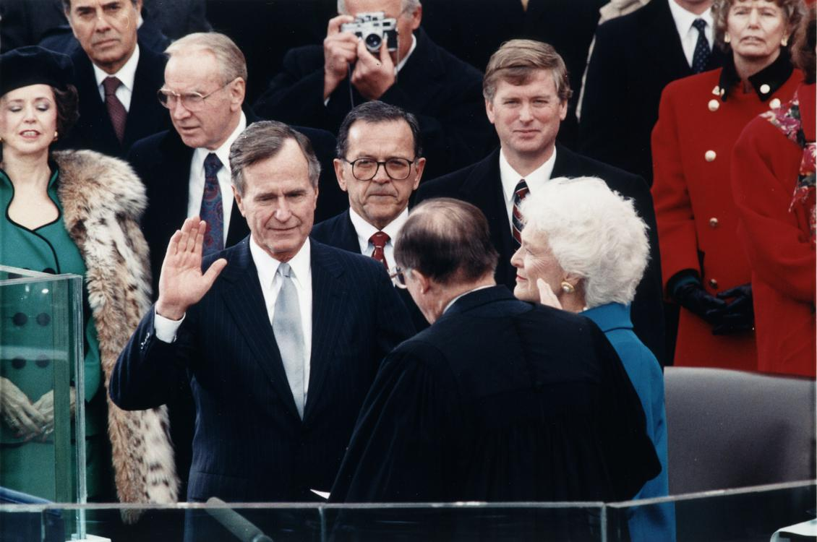  
*Chief Justice William Rehnquist administers the Presidential Oath of Office to George H. W. Bush during his inauguration ceremony at the United States Capitol on January 20, 1989.*

# Presidency (1989–1993)

* *In his inaugural address, Bush said:*
* *Bush was inaugurated on January 20, 1989, succeeding Ronald Reagan.*

Bush was inaugurated on January 20, 1989, succeeding Ronald Reagan. He entered office at a period of change in the world; the fall of the Berlin Wall came early in his presidency, and the collapse of the Soviet Union came in 1991. He ordered military operations in Panama and the Persian Gulf, and, at one point, was recorded as having a record-high approval rating of 89%.

In his inaugural address, Bush said:

# Domestic policy

# Economy

* *Early in his term, Bush faced the problem of what to do with leftover deficits spawned during the Reagan years.*
* *In the wake of a struggle with Congress, Bush was forced by the Democratic majority to raise tax revenues; as a result, many Republicans felt betrayed because Bush had promised "no new taxes" in his 1988 campaign.*
* *Bush later said that he wished that he had never signed the bill.*

Early in his term, Bush faced the problem of what to do with leftover deficits spawned during the Reagan years. At $220 billion in 1990, the deficit had tripled since 1980. Bush was dedicated to curbing the deficit, believing that America could not continue to be a leader in the world without doing so. He began an effort to persuade the Democratic controlled Congress to act on the budget; with Republicans believing that the best way was to cut government spending, and Democrats convinced that the only way would be to raise taxes, Bush faced problems when it came to consensus building.

In the wake of a struggle with Congress, Bush was forced by the Democratic majority to raise tax revenues; as a result, many Republicans felt betrayed because Bush had promised "no new taxes" in his 1988 campaign. Perceiving a means of revenge, Republican congressmen defeated Bush's proposal, which would enact spending cuts and tax increases that would reduce the deficit by $500 billion over five years. Scrambling, Bush accepted the Democrats' demands for higher taxes and more spending, which alienated him from Republicans and gave way to a sharp decrease in popularity. Bush later said that he wished that he had never signed the bill. Near the end of the 101st Congress, the president and congressional members reached a compromise on a budget package that increased the marginal tax rate and phased out exemptions for high-income taxpayers. Although he originally demanded a reduction in the capital gains tax, Bush relented on this issue as well. This agreement with the Democratic leadership in Congress proved to be a turning point in the Bush presidency; his popularity among Republicans never fully recovered.

Coming at around the same time as the budget deal, America entered into a mild recession, which lasted for six months. Many government programs, such as welfare, increased. As the unemployment rate edged upward in 1991, Bush signed a bill providing additional benefits for unemployed workers. The year 1991 was marked by many corporate reorganizations, which laid off a substantial number of workers. Many now unemployed were Republicans and independents, who had believed that their jobs were secure.

By his second year in office, Bush was told by his economic advisors to stop dealing with the economy, as they believed that he had done everything necessary to ensure his reelection. By 1992, interest and inflation rates were the lowest in years, but by midyear the unemployment rate reached 7.8%, the highest since 1984. In September 1992, the Census Bureau reported that 14.2% of all Americans lived in poverty. At a press conference in 1990, Bush told reporters that he found foreign policy more enjoyable.

# Education

* *Bush concurrently declared he would be involved with a reform of troubled schools and accused the Democrat-controlled Congress of "fighting tooth and nail against our most important reforms".*
* *In a November 25 appearance in Columbus, Ohio, Bush joined Governor of Ohio George Voinovich in formally announcing a state version of his education policy, "Ohio 2000".*

On April 5, 1989, Bush submitted to Congress the Educational Excellence Act of 1989, a seven-program education legislative proposal with the intent of achieving "a better-educated America." The proposal was opposed by Republicans seeking to shrink government's role in education and met with a lack of enthusiasm by Democrats. A week after submitting the proposal, Bush said his administration was seeking to provide waivers on "some regulations for poorer communities" and create "a kind of performance-driven partial deregulation of education" that would grant federal funding when schools showed high levels of accountability coupled with academic performance. Later in the year, from September 27 to 28, Bush held a summit with American governors dedicated solely to education reform at the University of Virginia, the group forming a consensus to overhaul the American education system for the country's students to be closer in test scores in science, mathematics, and literacy.

In his 1990 State of the Union Address, Bush revealed that his administration would spearhead an increase in American high school graduation rates to 90%, along with making American students "first in the world" in the subjects of math and science by 2000. In a speech in the White House East Room on April 18, 1991, Bush called for both public and private citizens to become involved with education reform: "To those who want to see real improvement in American education, I say there will be no renaissance without revolution. It's time we held our schools, and ourselves, accountable for results." On June 3, Bush advocated for community participation in reforming the national education system and insisting America 2000 would fail "if we try to do it from Washington itself." On October 4, Bush met with representatives of the New American Schools Development Corp. at Camp David as the organization sought US$200 million for education reform to aid with the forming of "new learning environments". In a November 25 appearance in Columbus, Ohio, Bush joined Governor of Ohio George Voinovich in formally announcing a state version of his education policy, "Ohio 2000". Bush concurrently declared he would be involved with a reform of troubled schools and accused the Democrat-controlled Congress of "fighting tooth and nail against our most important reforms".

On July 23, 1992, Bush signed the Higher Education Amendments of 1992, a resumption of "many programs in the Higher Education Act of 1965."

  
*President Bush participates in a full cabinet meeting in the Cabinet Room in July 1992*

# Major initiatives

* *In dealing with the environment, Bush reauthorized the Clean Air Act, requiring cleaner burning fuels.*
* *Bush signed the Immigration Act of 1990, which led to a 40 percent increase in legal immigration to the United States.*
* *On November 21, 1989, Bush signed a measure that guaranteed reparations to Japanese-Americans who were relocated into internment camps during World War II.*

During a speech to commemorate the 20th anniversary of the Apollo 11 moon landing, Bush announced a vision to complete Space Station Freedom, resume exploration of the moon and begin exploration of Mars. Although a space station was eventually constructed (work on the International Space Station began in 1998), other projects were quashed due to NASA budgetary issues. In 1998, Bush received the Rotary National Award for Space Achievement's National Space Trophy for his pioneering leadership of the U.S. space program.

During his presidency, Bush signed a number of major bills into law, including the Americans with Disabilities Act of 1990; this was one of the most pro-civil rights bills in decades. He was also the only president to successfully veto a civil rights act, the job-discrimination protection Civil Rights Act of 1990. Bush feared racial quotas would be imposed, but later approved the watered-down Civil Rights Act of 1991. He worked to increase federal spending for education, childcare, and advanced technology research. He also signed the Radiation Exposure Compensation Act, which provides monetary compensation of people who had contracted cancer and a number of other specified diseases as a direct result of their exposure to atmospheric nuclear weapons testing undertaken by the United States during the Cold War, or their exposure to high levels of radon while doing uranium mining. In dealing with the environment, Bush reauthorized the Clean Air Act, requiring cleaner burning fuels. He quarreled with Congress over an eventually signed bill to aid police in capturing criminals, and signed into law a measure to improve the nation's highway system. Bush signed the Immigration Act of 1990, which led to a 40 percent increase in legal immigration to the United States.

On November 21, 1989, Bush signed a measure that guaranteed reparations to Japanese-Americans who were relocated into internment camps during World War II. Congress authorized US$20,000 (equivalent to $40,424 in 2018) for each survivor.

Bush became a life member of the National Rifle Association early in 1988 and had campaigned as a "pro-gun" candidate with the NRA's endorsement. In March 1989, he placed a temporary ban on the import of certain semiautomatic rifles. This action cost him endorsement from the NRA in 1992. Bush publicly resigned his life membership in the organization after receiving a form letter from the NRA depicting agents of the Bureau of Alcohol, Tobacco, and Firearms as "jack-booted thugs." He called the NRA letter a "vicious slander on good people."

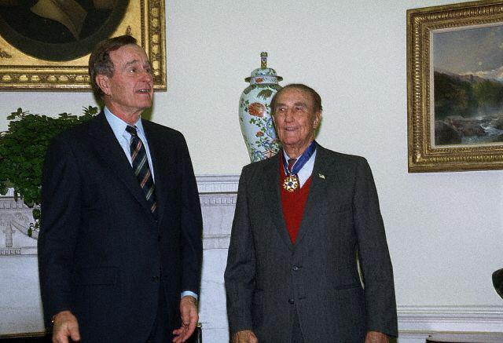  
*President Bush presents Senator Strom Thurmond with the Presidential Medal of Freedom in a ceremony in the Oval Office.*

# Points of Light

* *President Bush was joined by presidents Jimmy Carter, Bill Clinton, and George W. Bush to highlight the role volunteer service plays in people's lives.*
* *On October 16, 2009, President Barack Obama held a Presidential Forum on Service hosted by former president George H. W. Bush and Points of Light at the George Bush Presidential Library Center on the campus of Texas A&M University.*

President Bush devoted attention to voluntary service as a means of solving some of America's most serious social problems. He often used the "thousand points of light" theme to describe the power of citizens to solve community problems. In his 1989 inaugural address, President Bush said, "I have spoken of a thousand points of light, of all the community organizations that are spread like stars throughout the Nation, doing good."

Four years later, in his report to the nation on the Points of Light Movement, President Bush said, "Points of Light are the soul of America. They are ordinary people who reach beyond themselves to touch the lives of those in need, bringing hope and opportunity, care and friendship. By giving so generously of themselves, these remarkable individuals show us not only what is best in our heritage but what all of us are called to become."

In 1990, the Points of Light Foundation was created as a nonprofit organization in Washington D.C. to promote this spirit of volunteerism. In 2007, the Points of Light Foundation merged with the Hands on Network with the goal of strengthening volunteerism, streamlining costs and services and deepening impact. Points of Light, the organization created through this merger, has approximately 250 affiliates in 22 countries and partnerships with thousands of nonprofits and companies dedicated to volunteer service around the world. In 2012, Points of Light mobilized 4 million volunteers in 30 million hours of service worth $635 million.

On October 16, 2009, President Barack Obama held a Presidential Forum on Service hosted by former president George H. W. Bush and Points of Light at the George Bush Presidential Library Center on the campus of Texas A&M University. The event celebrated the contributions of more than 4,500 Daily Point of Light award winners and honored President Bush's legacy of service and civic engagement.

In 2011, Points of Light paid tribute to President George H. W. Bush and volunteer service at Washington, D.C.'s John F. Kennedy Center for the Performing Arts. President Bush was joined by presidents Jimmy Carter, Bill Clinton, and George W. Bush to highlight the role volunteer service plays in people's lives.

# Daily Point of Light Award

* *President Bush created the Daily Point of Light Award in 1989 to recognize ordinary Americans from all walks of life taking direct and consequential voluntary action in their communities to solve serious social problems.*
* *The Daily Point of Light continues to be awarded by Points of Light and up until his death President Bush continued to sign all of the awards.*
* *On July 15, 2013, President Barack Obama welcomed President Bush to the White House to celebrate the 5,000th Daily Point of Light Award.*

President Bush created the Daily Point of Light Award in 1989 to recognize ordinary Americans from all walks of life taking direct and consequential voluntary action in their communities to solve serious social problems. The president focused great attention on these individuals and organizations, both to honor them for their tremendous work and to call the nation to join them and multiply their efforts. By the end of his administration, President Bush had recognized 1,020 Daily Points of Light representing all 50 states and addressing issues ranging from care for infants and teenagers with AIDS to adult illiteracy and from gang violence to job training for the homeless. The Daily Point of Light continues to be awarded by Points of Light and up until his death President Bush continued to sign all of the awards.

On July 15, 2013, President Barack Obama welcomed President Bush to the White House to celebrate the 5,000th Daily Point of Light Award. They bestowed the award on Floyd Hammer and Kathy Hamilton of Union, Iowa, for their work founding Outreach, a nonprofit which delivers free meals to hungry children in 15 countries.

# Judicial appointments

* *Bush made two appointments to the Supreme Court of the United States — David Souter in 1990, and Clarence Thomas in 1991.*
* *Bush also experienced a number of judicial appointment controversies, as 11 nominees for 10 federal appellate judgeships were not processed by the Democratically-controlled Senate Judiciary Committee.*

Bush made two appointments to the Supreme Court of the United States — David Souter in 1990, and Clarence Thomas in 1991. Additionally, he appointed 42 judges to the United States courts of appeals and 148 judges to the United States district courts. Among these was Vaughn Walker, a gay man who ruled that California's Proposition 8 amendment was unconstitutional. Bush also experienced a number of judicial appointment controversies, as 11 nominees for 10 federal appellate judgeships were not processed by the Democratically-controlled Senate Judiciary Committee.

# Foreign policy

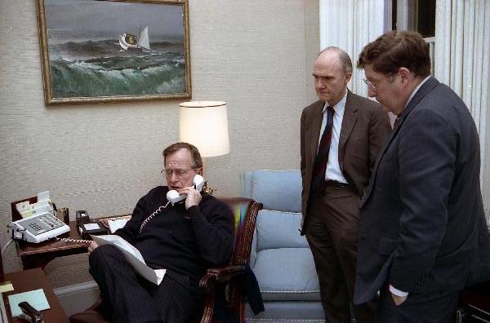  
*Bush speaks on the telephone regarding Operation Just Cause as General Brent Scowcroft and Chief of Staff John H. Sununu look on, 1989*

# Panama

* *President Bush and First Lady Barbara Bush visited Panama in June 1992, to give support to the first post-invasion Panamanian government.*
* *The visit was marred by protests which broke into gunfire and tear gas, forcing Bush to depart a rally.*
* *Bush shuttered the U.S. embassy and removed the U.S.*
* *In response, Bush sent 2,000 more troops to the country, where they began conducting regular military exercises in Panamanian territory (in violation of prior treaties).*

In the 1980s, Panamanian leader Manuel Noriega, a once U.S.-supportive leader who was later accused of spying for Fidel Castro and using Panama to traffic drugs into the United States, was one of the most recognizable names in America and was constantly in the press. The struggle to remove him from power began in the Reagan administration, when economic sanctions were imposed on the country; this included prohibiting American companies and government from making payments to Panama and freezing $56 million in Panamanian funds in American banks. Reagan sent more than 2,000 American troops to Panama as well. Unlike Reagan, Bush was able to remove Noriega from power, but his administration's unsuccessful post-invasion planning hindered the needs of Panama during the establishment of the young democratic government.

In May 1989, Panama held democratic elections, in which Guillermo Endara was elected president; the results were then annulled by Noriega's government. In response, Bush sent 2,000 more troops to the country, where they began conducting regular military exercises in Panamanian territory (in violation of prior treaties). Bush shuttered the U.S. embassy and removed the U.S. Ambassador from the country, and dispatched additional troops to Panama to prepare the way for an upcoming invasion. Noriega suppressed an October military coup attempt and massive protests in Panama against him, but after a U.S. serviceman was shot by Panamanian forces in December 1989, Bush ordered 24,000 troops into the Central American nation with an objective of removing Noriega from power; "Operation Just Cause" was a large-scale American military operation, and the first in more than 40 years that was not related to the Cold War.

The mission was controversial, but American forces achieved control of the country and Endara assumed the presidency. Noriega surrendered to the United States and was convicted and imprisoned on racketeering and drug trafficking charges in April 1992. President Bush and First Lady Barbara Bush visited Panama in June 1992, to give support to the first post-invasion Panamanian government. The visit was marred by protests which broke into gunfire and tear gas, forcing Bush to depart a rally.

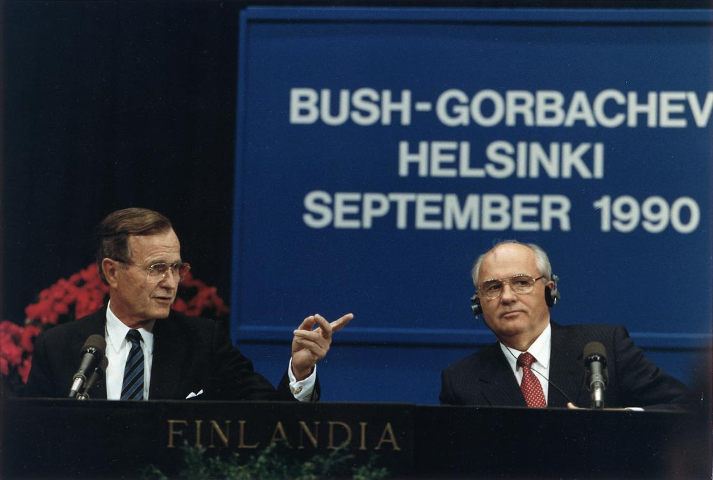  
*Bush and Mikhail Gorbachev in Helsinki summit in 1990*

  
*George and Barbara Bush with President Boris Yeltsin, Russia's first post-Soviet, freely elected leader, at the White House, Washington, D.C. in 1992*

# Soviet Union

* *After the dissolution of the USSR, President Bush and Russian president Boris Yeltsin declared a U.S.–Russian strategic partnership, marking the end of the Cold War.*
* *Bush described START as "a significant step forward in dispelling half a century of mistrust".*
* *European leaders, including François Mitterrand and Margaret Thatcher, encouraged Bush to meet with Gorbachev.*

Bush met with Soviet General Secretary Mikhail Gorbachev at the Malta Summit in December 1989, just after the fall of the Berlin Wall. His administration had been under intense pressure to meet with the Soviets, but not all initially found the conference to be a step in the right direction. General Brent Scowcroft, among others, was apprehensive about the meeting, saying that it might be "premature" due to concerns that, according to Condoleezza Rice, "expectations [would be] set that something was going to happen, where the Soviets might grandstand and force [the U.S.] into agreements that would ultimately not be good for the United States." European leaders, including François Mitterrand and Margaret Thatcher, encouraged Bush to meet with Gorbachev. Although no agreements were signed, the meeting was received as an important step to the end of the Cold War. When asked about nuclear war, Gorbachev responded, "I assured the President of the United States that the Soviet Union would never start a hot war against the United States of America, and we would like our relations to develop in such a way that they would open greater possibilities for cooperation.... This is just the beginning. We are just at the very beginning of our road, long road to a long-lasting, peaceful period."

Another summit was held in July 1991, where the Strategic Arms Reduction Treaty (START I) was signed by Bush and Gorbachev in Moscow. The treaty took nine years to negotiate, and was the first major arms agreement since the signing of the Intermediate-Range Nuclear Forces Treaty by Reagan and Gorbachev in 1987. The contentions in START would reduce the strategic nuclear weapons of the United States and the USSR by about 35% over seven years, and the Soviet Union's land-based intercontinental ballistic missiles would be cut by 50%. Bush described START as "a significant step forward in dispelling half a century of mistrust".

Bush and Condoleezza Rice were criticized for their very weak tone and miscalculation in the Chicken Kiev speech on August 1, 1991, three weeks before the Declaration of Independence of Ukraine, four months before the 92.26%-confirmed Ukrainian independence referendum, and 145 days before the dissolution of the Soviet Union. After the dissolution of the USSR, President Bush and Russian president Boris Yeltsin declared a U.S.–Russian strategic partnership, marking the end of the Cold War.

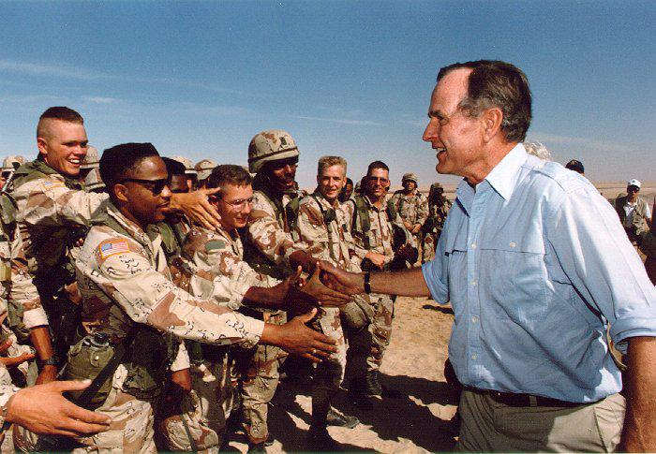  
*President Bush visits American troops in Saudi Arabia on Thanksgiving Day, 1990*

  
*Bush meets with Robert Gates, General Colin Powell, Secretary Dick Cheney and others about the situation in the Persian Gulf and Operation Desert Shield, January 15, 1991*

# Gulf War

* *Bush's approval ratings skyrocketed after the successful offensive.*
* *Opponents further charged that Bush should have continued the attack, pushing Hussein's army back to Baghdad, then removing him from power.*
* *Bush made the decision to stop the offensive after a mere 100 hours.*
* *Bush rejected this proposal and insisted on a complete withdrawal of Iraqi forces.*

On August 2, 1990, Iraq, led by Saddam Hussein, invaded its oil-rich neighbor to the south, Kuwait; Bush condemned the invasion and began rallying opposition to Iraq in the United States and among European, Asian, and Middle Eastern allies. Secretary of Defense Dick Cheney traveled to Saudi Arabia to meet with King Fahd, who requested United States military aid in the matter, fearing a possible invasion of his country as well. The request was met initially with Air Force fighter jets. Iraq made attempts to negotiate a deal that would have allowed the country to take control of half of Kuwait. Bush rejected this proposal and insisted on a complete withdrawal of Iraqi forces. The planning of a ground operation by U.S.-led coalition forces began forming in September 1990, headed by General Norman Schwarzkopf, Jr.. Bush spoke before a joint session of the United States Congress regarding the authorization of air and land attacks, laying out four immediate objectives: "Iraq must withdraw from Kuwait completely, immediately, and without condition. Kuwait's legitimate government must be restored. The security and stability of the Persian Gulf must be assured. And American citizens abroad must be protected." He then outlined a fifth, long-term objective: "Out of these troubled times, our fifth objective — a new world order — can emerge: a new era — freer from the threat of terror, stronger in the pursuit of justice, and more secure in the quest for peace. An era in which the nations of the world, East and West, North and South, can prosper and live in harmony ... A world where the rule of law supplants the rule of the jungle. A world in which nations recognize the shared responsibility for freedom and justice. A world where the strong respect the rights of the weak." With the United Nations Security Council opposed to Iraq's violence, Congress authorized the use of military force with a set goal of returning control of Kuwait to the Kuwaiti government, and protecting America's interests abroad.

Early on the morning of January 17, 1991, allied forces launched the first attack, which included more than 4,000 bombing runs by coalition aircraft. This pace would continue for the next four weeks, until a ground invasion was launched on February 24, 1991. Allied forces penetrated Iraqi lines and pushed toward Kuwait City, while on the west side of the country, forces were intercepting the retreating Iraqi army. Bush made the decision to stop the offensive after a mere 100 hours. Critics labeled this decision premature, as hundreds of Iraqi forces were able to escape; Bush responded by saying that he wanted to minimize U.S. casualties. Opponents further charged that Bush should have continued the attack, pushing Hussein's army back to Baghdad, then removing him from power. Bush explained that he did not give the order to overthrow the Iraqi government because it would have "incurred incalculable human and political costs... We would have been forced to occupy Baghdad and, in effect, rule Iraq."

Bush's approval ratings skyrocketed after the successful offensive. Additionally, President Bush and Secretary of State Baker felt the coalition victory had increased U.S. prestige abroad and believed there was a window of opportunity to use the political capital generated by the coalition victory to revitalize the Arab-Israeli peace process. The administration immediately returned to Arab-Israeli peacemaking following the end of the Gulf War; this resulted in the Madrid Conference, later in 1991.

Several Iraqi families living in Belgium who lost loved ones in the Gulf War launched a lawsuit against George H. W. Bush for committing what they claim are war crimes in the 1991 Amiriyah shelter bombing in Baghdad, which killed more than 400 civilians. The suit was brought under Belgium's universal jurisdiction guarantees in March 2003. According to the Human Rights Watch, the Amiriyah shelter bombing was "a serious violation of the laws of war."

# Somali Civil War

* *A lame duck president, Bush launched Operation Restore Hope the following day under which the United States would assume command in accordance with Resolution 794.*
* *The Bush administration proposed American aid to the region by assisting in creating a secure environment for humanitarian efforts and UN Security Council Resolution 794 was unanimously adopted by the Security Council on December 3, 1992.*

Faced with a humanitarian disaster in Somalia which was exacerbated by a complete breakdown in civil order, the United Nations had created the UNOSOM I mission in April 1992 to aid the situation through humanitarian efforts, though the mission failed. The Bush administration proposed American aid to the region by assisting in creating a secure environment for humanitarian efforts and UN Security Council Resolution 794 was unanimously adopted by the Security Council on December 3, 1992. A lame duck president, Bush launched Operation Restore Hope the following day under which the United States would assume command in accordance with Resolution 794. Fighting would escalate and continue into the Clinton administration.

# Japan

* *During an April 28, 1989 appearance in the press room of the White House, Bush announced that the U.S. would continue a deal with Japan to produce the FSX advanced fighter jet.*
* *The following day — the fiftieth anniversary of the attack — Bush accepted Japan's apology for the event that drew the United States into World War II.*
* *Bush urged that progress be made in improving relations between the U.S. and Japan.*

During an April 28, 1989 appearance in the press room of the White House, Bush announced that the U.S. would continue a deal with Japan to produce the FSX advanced fighter jet. He said that promises had been made that American jobs and technology would be safe and the proposal would bolster security for both the U.S. and Japan.

On March 12, 1990, Bush met for an hour with former Prime Minister of Japan Noboru Takeshita to discuss shared economic issues and "the fact that their solution will require extraordinary efforts on both sides of the Pacific."

On December 6, 1991, Japanese Prime Minister Kiichi Miyazawa apologized to the United States for the attack on Pearl Harbor. The following day — the fiftieth anniversary of the attack — Bush accepted Japan's apology for the event that drew the United States into World War II. Bush urged that progress be made in improving relations between the U.S. and Japan.

# Israel

* *Most Israelis wanted the Israeli military to retaliate, but President Bush advised the Israelis not to.*
* *Bush praised Prime Minister Shamir for his leadership during the crisis.*
* *On August 11, 1992, following a meeting between President Bush and Prime Minister Yitzhak Rabin, Bush announced he would seek the approval of Congress to bestow Israel with up to $10 billion in loan guarantees to assist the country with its absorbing of Soviet Union immigrants.*

On June 18, 1990, White House Press Secretary Marlin Fitzwater confirmed President Bush had sent Prime Minister of Israel Yitzhak Shamir a letter in which he congratulated the latter on his election and urged him to support the proposed "Shamir initiative for peace," which would involve the participation of Palestinian Arabs in local elections. On June 20, Bush suspended American dialogue with the Palestine Liberation Organization for the latter's refusal to condemn the Palestinian guerrilla raid of an Israeli beach the previous month.

Iraq attacked Israel with Scud missiles during the Gulf War. Most Israelis wanted the Israeli military to retaliate, but President Bush advised the Israelis not to. Bush praised Prime Minister Shamir for his leadership during the crisis.

On August 11, 1992, following a meeting between President Bush and Prime Minister Yitzhak Rabin, Bush announced he would seek the approval of Congress to bestow Israel with up to $10 billion in loan guarantees to assist the country with its absorbing of Soviet Union immigrants.

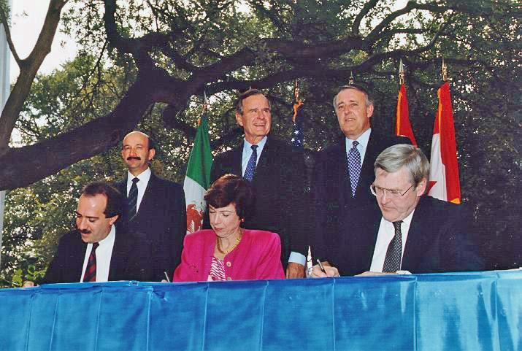  
*Standing: President Carlos Salinas, President Bush, Prime Minister Brian Mulroney; Seated: Jaime Serra Puche, Carla Hills, and Michael Wilson at the NAFTA Initialing Ceremony, October 1992*

# NAFTA

* *Bush needed a renewal of negotiating authority to move forward with the NAFTA trade talks.*
* *President Bush announced the completion of NAFTA during a White House Rose Garden appearance on August 12, 1992, calling it the "beginning of a new era".*
* *The Bush administration and the Progressive Conservative Prime Minister of Canada Brian Mulroney spearheaded the negotiations of the North American Free Trade Agreement (NAFTA).*

The Bush administration and the Progressive Conservative Prime Minister of Canada Brian Mulroney spearheaded the negotiations of the North American Free Trade Agreement (NAFTA). The agreement would eliminate the majority of tariffs on products that were traded among the United States, Canada, and Mexico. This would encourage trade among the countries. The treaty also restricted patents, copyrights, and trademarks, and outlined the removal of investment restrictions among the three countries. President Bush announced the completion of NAFTA during a White House Rose Garden appearance on August 12, 1992, calling it the "beginning of a new era".

The agreement came under heavy scrutiny amongst mainly Democrats, who charged that NAFTA resulted in a loss of American jobs. NAFTA also contained no provisions for labor rights; according to the Bush administration, the trade agreement would generate economic resources necessary to enable Mexico's government to overcome problems of funding and enforcement of its labor laws. Bush needed a renewal of negotiating authority to move forward with the NAFTA trade talks. Such authority would enable the president to negotiate a trade accord that would be submitted to Congress for a vote, thereby avoiding a situation in which the president would be required to renegotiate with trading partners those parts of an agreement that Congress wished to change. While initial signing was possible during his term, negotiations made slow, but steady, progress. President Clinton would go on to make the passage of NAFTA a priority for his administration, despite its conservative and Republican roots—with the addition of two side agreements—to achieve its passage in 1993.

The treaty has since been defended, as well as criticized further. The American economy has grown 54% since the adoption of NAFTA in 1993, with 25 million new jobs created; this was seen by some as evidence of NAFTA being beneficial to the United States. With talk in early 2008 regarding a possible American withdrawal from the treaty, Carlos M. Gutierrez, the then United States Secretary of Commerce, wrote, "Quitting NAFTA would send economic shock waves throughout the world, and the damage would start here at home." But John J. Sweeney, the then president of the AFL-CIO, wrote in The Boston Globe that "the U.S. trade deficit with Canada and Mexico ballooned to twelve times its pre-NAFTA size, reaching $111 billion in 2004."

# Pardons

* *Walsh noted that in issuing the pardons Bush may have been preempting being implicated himself in the crimes of Iran-Contra by evidence that was to come to light during the Weinberger trial, and noted that there was a pattern of "deception and obstruction" by Bush, Weinberger and other senior Reagan administration officials.*
* *In keeping with tradition, Bush issued a series of pardons during his last days in office.*

In keeping with tradition, Bush issued a series of pardons during his last days in office. On December 24, 1992, he granted executive clemency to six former senior government officials implicated in the Iran-Contra scandal of the late 1980s, most prominently the former Secretary of Defense Caspar Weinberger. Bush described Weinberger, who was scheduled to stand trial starting on January 5, 1993, for criminal charges related to Iran-Contra, as a "true American patriot".

In addition to Weinberger, Bush pardoned Duane R. Clarridge, Clair E. George, who had been convicted to felonies in connection with the Iran-Contra scandal, Robert C. McFarlane, Elliott Abrams, and Alan Fiers, all of whom had been indicted and/or convicted of criminal charges by an Independent Counsel headed by Lawrence Walsh, who headed the investigation of Reagan Administration officials' criminal conduct in the Iran-Contra scandal. In response to these Bush pardons, Lawrence Walsh stated that "the Iran-Contra cover-up, which has continued for more than six years, has now been completed." Walsh noted that in issuing the pardons Bush may have been preempting being implicated himself in the crimes of Iran-Contra by evidence that was to come to light during the Weinberger trial, and noted that there was a pattern of "deception and obstruction" by Bush, Weinberger and other senior Reagan administration officials.

# Honorary degrees

* *George H. W. Bush received honorary degrees from several American and International Universities, including:*

George H. W. Bush received honorary degrees from several American and International Universities, including:

# Awards and honors

* *In 1991, the U.S. Navy Memorial Foundation awarded Bush its Lone Sailor award for his naval service and his subsequent government service.*

In 1990, Time magazine named him the Man of the Year. In 1991, the U.S. Navy Memorial Foundation awarded Bush its Lone Sailor award for his naval service and his subsequent government service. In 1993, he was made an Honorary Knight Grand Cross of the Order of the Bath by Queen Elizabeth II. In 2009, he received the PGA Tour Lifetime Achievement Award and was inducted into the World Golf Hall of Fame two years later.

# 1992 presidential campaign

* *Several key factors led to Bush's defeat.*
* *Once he had secured the nomination, Bush faced the Democratic nominee, Arkansas Governor Bill Clinton.*
* *In early 1992, Bush announced that he would seek a second term.*
* *Conservative political columnist Pat Buchanan challenged Bush for the Republican nomination.*

In early 1992, Bush announced that he would seek a second term. A coalition victory in the Persian Gulf War and high approval ratings made re-election seem likely. As a result, many leading Democrats declined to seek their party's presidential nomination. On the negative side, Bush's popularity was reduced by an economic recession and doubts of whether he properly ended the Gulf War.

Conservative political columnist Pat Buchanan challenged Bush for the Republican nomination. He shocked political pundits by finishing second, with 37% of the vote in the New Hampshire primary. Bush responded by adopting more conservative positions on issues, in an attempt to undermine Buchanan's base. Once he had secured the nomination, Bush faced the Democratic nominee, Arkansas Governor Bill Clinton. Clinton attacked Bush as a politician who was not doing enough to assist the working middle-class and being "out of touch" with the common man, a notion reinforced by reporter Andrew Rosenthal's false report that Bush was "astonished" to see a demonstration of a supermarket scanner.

In early 1992, the race took an unexpected twist when Texas billionaire H. Ross Perot launched a third party bid, claiming that neither Republicans nor Democrats could eliminate the deficit and make government more efficient. His message appealed to voters across the political spectrum disappointed with both parties' perceived fiscal irresponsibility. Perot later bowed out of the race for a short time, then reentered.

Clinton had originally been in the lead, until Perot reentered, tightening the race significantly. As Election Day neared, the polls suggested that the race was a dead-heat, but Clinton pulled out on top, with 370 electoral votes to Bush's 168 votes. Perot won 19% of the popular vote, one of the highest totals for a third party candidate in U.S. history, drawing equally from both major candidates, according to exit polls.

Several key factors led to Bush's defeat. The ailing economy that arose from recession may have been the main factor in Bush's loss. On Election Day, 7 in 10 voters said that the economy was either "not so good" or "poor". On the eve of the 1992 election unemployment reports of 7.8% (the highest since 1984), and the economic recession overall contributed significantly to a sharp decline in Bush's approval rating – to just 37%.

Conservative Republicans pointed out that Bush's 1990 agreement to raise taxes contradicted his famous "Read my lips: no new taxes" pledge. In doing so, Bush alienated many members of his conservative base, losing their support for his re-election. According to one survey, of the voters who cited Bush's broken "No New Taxes" pledge as "very important", two thirds voted for Bill Clinton. Bush had raised taxes in an attempt to address an increasing budget deficit, which has largely been attributed to the Reagan tax cuts and military spending of the 1980s. The tax revenue increase had not hurt his approval rating to the extent that it prevented it from reaching its highest level, 89%, by February 1991, during the Gulf War, and four months after the tax vote.

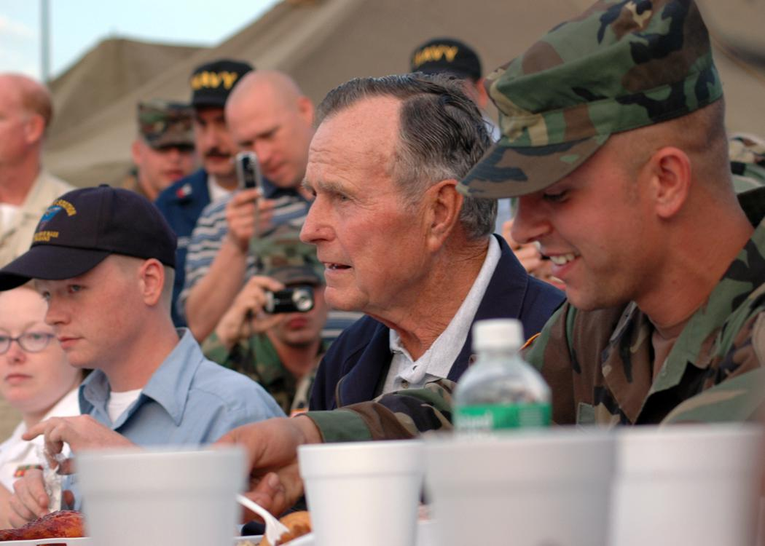  
*Bush visits NAS JRB, New Orleans personnel before he receives briefs on the status of Joint Task Force Katrina relief efforts, October 2005*

# Public image

* *By December 2008, 60% of Americans gave Bush's presidency a positive rating.*
* *Bush put that image to rest when he displayed evident fury during an interview with Dan Rather on January 25, 1988.*
* *Bush's campaign director Roger Ailes and others were concerned that Bush was seen as a "wimp."*
* *Bush was widely seen as a "pragmatic caretaker" president who lacked a unified and compelling long-term theme in his efforts.*

Bush was widely seen as a "pragmatic caretaker" president who lacked a unified and compelling long-term theme in his efforts. Indeed, Bush's sound bite where he refers to the issue of overarching purpose as "the vision thing" has become a metonym applied to other political figures accused of similar difficulties. "He does not say why he wants to be there", wrote columnist George Will, "so the public does not know why it should care if he gets his way".

His Ivy League and prep school education led to warnings by advisors that his image was too "preppy" in 1980, which resulted in deliberate efforts in his 1988 campaign to shed the image, including meeting voters at factories and shopping malls, abandoning set speeches. Bush's campaign director Roger Ailes and others were concerned that Bush was seen as a "wimp." Bush put that image to rest when he displayed evident fury during an interview with Dan Rather on January 25, 1988.

His ability to gain broad international support for the Gulf War and the war's result were seen as both a diplomatic and military triumph, rousing bipartisan approval, though his decision to withdraw without removing Saddam Hussein left mixed feelings, and attention returned to the domestic front and a souring economy. A New York Times article mistakenly depicted Bush as being surprised to see a supermarket barcode reader; the report of his reaction exacerbated the notion that he was "out of touch". Amid the early 1990s recession, his image shifted from "conquering hero" to "politician befuddled by economic matters".

Although Bush became the first elected Republican president since Hoover in 1932 to lose a reelection bid (facing a 34% approval rating leading up to the 1992 election), the mood did not last. Despite his defeat, Bush climbed back from election day approval levels to leave office in 1993 with a 56% job approval rating. By December 2008, 60% of Americans gave Bush's presidency a positive rating.

# Post-presidency (1993–2018)

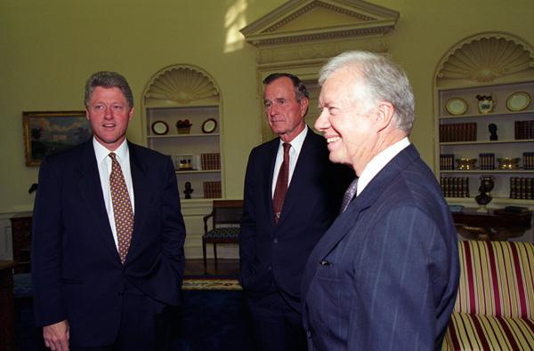  
*President Bill Clinton meeting with former presidents George H.W. Bush and Jimmy Carter at the White House in September 1993*

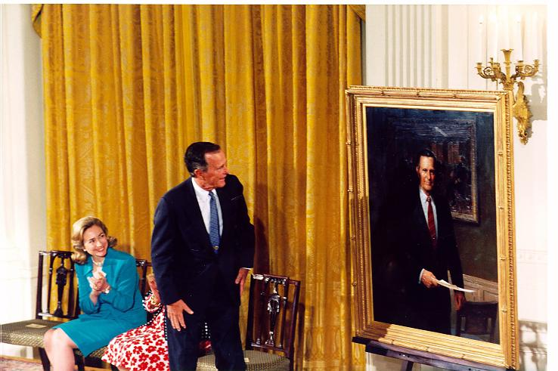  
 *The unveiling of an official portrait of George H. W. Bush at the East Room of the White House, 1995*

# During Clinton presidency

* *In September 1995, Bush met with President of Vietnam Lê Đức Anh and party secretary Đỗ Mười in Vietnam.*
* *Bush's experience with debating Clinton prompting Dole to seek out his advice.*
* *After the results came in, the elder Bush told ABC, "I have very mixed emotions.*
* *In April 1994, Bush attended the funeral of Richard Nixon.*

Upon leaving office, Bush retired with his wife, Barbara, and temporarily moved into a friend's house near the Tanglewood community of Houston as they prepared to build a permanent retirement house nearby. Ultimately they built their retirement house in the community of West Oaks, near Tanglewood. They had a presidential office within the Park Laureate Building on Memorial Drive. Mimi Swartz of National Geographic wrote that "The Bushes are too studiously sedate to live in River Oaks". They spent their summers at Walker's Point in Kennebunkport, Maine.

In 1993, Bush was targeted in an assassination plot when he visited Kuwait to commemorate the coalition's victory over Iraq in the Gulf War. Kuwaiti authorities arrested 17 people who were allegedly involved in using a car bomb in an attempt to kill Bush. Through interviews with the suspects and examinations of the bomb's circuitry and wiring, the FBI established that the plot had been directed by the Iraqi Intelligence Service. A Kuwaiti court later convicted all but one of the defendants. Two months later, Clinton retaliated when he ordered the firing of 23 cruise missiles at Iraqi Intelligence Service headquarters in Baghdad. The day before the strike, U.S. Ambassador to the United Nations Madeleine Albright went before the Security Council to present evidence of the Iraqi plot. After the missiles were fired, Vice President Al Gore said the attack "was intended to be a proportionate response at the place where this plot" to assassinate Bush "was hatched and implemented".

In September 1993, Bush and other living former presidents were invited back to the White House for an Arab-Israeli peace accord. They also made the case to Clinton for a repeal of NAFTA.

In April 1994, Bush attended the funeral of Richard Nixon.

In the 1994 gubernatorial elections, his sons George W. and Jeb concurrently ran for Governor of Texas and Governor of Florida. The elder Bush frequently telephoned their respective campaign headquarters for updates on the races. George W. won his race against Ann Richards while Jeb lost to Lawton Chiles. After the results came in, the elder Bush told ABC, "I have very mixed emotions. Proud father, is the way I would sum it all up." Jeb would again run for governor of Florida in 1998 and win at the same time that his brother George W. won re-election in Texas. It marked the second time in United States history that a pair of brothers served simultaneously as governors.

From 1993 to 1999, he served as the chairman of the board of trustees for Eisenhower Fellowships, and from 2007 to 2009 was chairman of the National Constitution Center.

On September 28, 1994, Bush said he was opposed to sending American troops to Haiti, citing his loss of confidence in President of Haiti Jean-Bertrand Aristide while speaking to business and civic leaders in Houston.

In an October 22, 1994 speech in Cancún, Mexico, Bush said history would vindicate him for not attempting to force Saddam Hussein out of power while in office: "The Mideast peace talks that offer hope to the world would never have started if we had done that. The Arabs would never have talked to us."

On July 17, 1995, Bush returned to the White House for the unveiling of his official portrait in an East Room ceremony attended by former members of his administration.

In September 1995, Bush met with President of Vietnam Lê Đức Anh and party secretary Đỗ Mười in Vietnam. On September 2, Bush and his son George W. participated in a parade commemorating World War II in Fredericksburg, Texas, where the elder Bush reasoned the United States had become united in the aftermath of the attack on Pearl Harbor and stressed America would have to stay involved in world affairs to continue its unity.

On July 26, 1996, Bush met with Republican presidential candidate Bob Dole and pledged he would do everything in his power to aid in securing a victory for Dole in the upcoming presidential election. The two met again in October while Dole was preparing for upcoming debates with President Clinton. Bush's experience with debating Clinton prompting Dole to seek out his advice.

In February 1997, Bush endorsed the chemical weapon banning treaty supported by United States Secretary of State Madeleine Albright, saying the United States would need to approve the treaty ahead of the April deadline.

In April 1997, Bush gave a speech at a convocation of a weekend conference analyzing his presidency and joined President Bill Clinton, former president Ford, and Nancy Reagan in signing the "Summit Declaration of Commitment" in advocating for participation by private citizens in solving domestic issues within the United States. Also in April 1997, the Houston Intercontinental Airport was renamed George Bush Intercontinental Airport after a proposal received the unanimous approval of the Houston City Council. The renaming took effect on May 2, with Bush presiding over the ceremonies as he took a 50-minute flight during the official changeover.

In August 1997, Bush agreed to be interviewed by The New York Times, as long as he would not be portrayed as giving credit to himself over the balanced budget deal that was composed by President Clinton and House Speaker Newt Gingrich. During a telephone interview, he stated his belief that history would show that his administration laid the groundwork for the agreement.

President Bush was Honorary Chairman of Points of Light, an international nonprofit dedicated to engaging more people and resources in solving serious social problems through voluntary service.

In January 1999, Bush spoke in the Old Senate chamber as part of a lecture series for Senators in an address warning against the collapse of political decorum and invasions into the privacy of individuals.

In February 1999, Bush was part of the American delegation to the funeral of King Hussein of Jordan in Amman.

In April 1999, Bush called for the release of former Chilean dictator Augusto Pinochet when Spain had him arrested and sought to try him for human rights violations.

In May 1999, Bush and his wife Barbara honored six senior citizens during the annual Ageless Heroes honors in Chicago, Illinois.

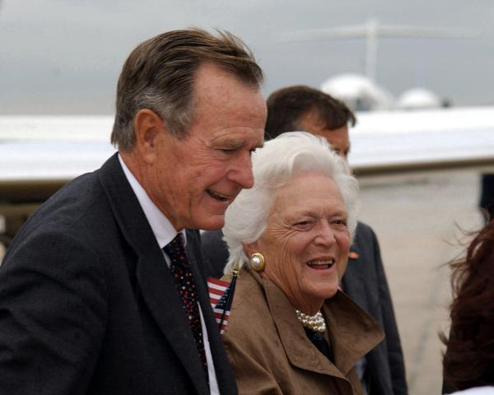  
*George and Barbara Bush, 2001*

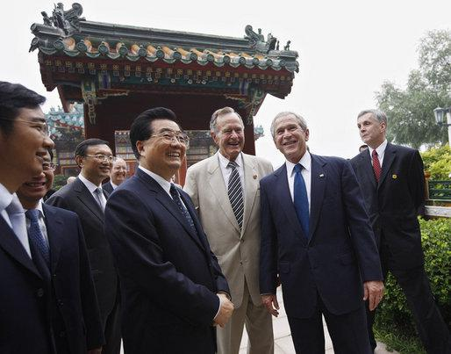  
*George H. W. Bush with son George W. Bush and China's president Hu Jintao in Beijing, People's Republic of China, August 10, 2008*

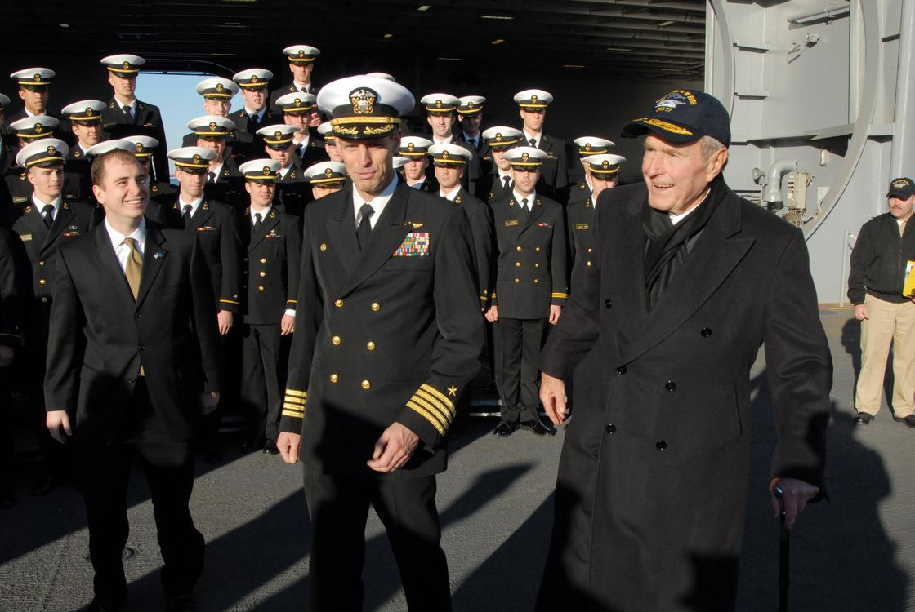  
*Capt. Kevin E. O'Flaherty, commanding officer of the aircraft carrier USS George H.W. Bush, escorts former president George H. W. Bush, 2009*

# During George W. Bush presidency

* *Through previous administrations, the elder Bush had ubiquitously been known as "George Bush" or "President Bush", but following his son's election the need to distinguish between them has made retronymic forms such as "George H. W. Bush" and "George Bush senior" and colloquialisms such as "Bush 41" and "Bush the Elder" much more common.*

His eldest son, George W. Bush, was inaugurated as the 43rd president of the United States on January 20, 2001, and re-elected in 2004. Through previous administrations, the elder Bush had ubiquitously been known as "George Bush" or "President Bush", but following his son's election the need to distinguish between them has made retronymic forms such as "George H. W. Bush" and "George Bush senior" and colloquialisms such as "Bush 41" and "Bush the Elder" much more common. H.W. Bush was traveling to Minnesota for a speaking engagement on the day of the September 11 attacks. George W. made multiple calls to get in contact with his father before the two men reconnected after the elder Bush had gone to a Brookfield, Wisconsin motel. Bush told biographer Jon Meacham that his son's vice president, Dick Cheney, underwent a change following the September 11 attacks: "His seeming knuckling under to the real hard-charging guys who want to fight about everything, use force to get our way in the Middle East."

In December 2002, George W. sought counsel from the elder Bush regarding Iraq and informed him of "my efforts to rally the Saudis, Jordanians, Turks, and others in the Middle East".

Following the fall of Baghdad, Bush praised George W. in an April 2003 email to the incumbent president. In a September 14, 2003 interview with BBC, Bush stated his support for a continuation of his son's war against terrorism and that the U.S. was in a better state in terms of protecting itself from terrorism than two years prior. While visiting Houston VA Medical Center on December 17, Bush told reporters of his satisfaction with the capture of Saddam Hussein.

President and Mrs. Bush attended the state funeral of Ronald Reagan in June 2004, and of Gerald Ford in January 2007. One month later, he was awarded the Ronald Reagan Freedom Award in Beverly Hills, California, by former First Lady Nancy Reagan. Despite Bush's political differences with Bill Clinton, reports acknowledged that the two former presidents had become friends. He and Clinton appeared together in television ads in 2005, encouraging aid for victims of Hurricane Katrina and the 2004 Indian Ocean earthquake and tsunami.

In October 2004, Bush endorsed Pete Sessions and Ted Poe in Texas congressional races.

In February 2006, Bush delivered a eulogy at the funeral of Coretta Scott King.

On March 2, 2006, President Bush announced that his father would lead the American delegation to the inauguration of the president-elect of the Republic of Portugal Aníbal Cavaco Silva.

In September 2006, Bush campaigned for New Jersey Senate candidate Thomas Kean Jr., praising him as well as stating his respect for Kean for calling on the resignation of U.S. Defense Secretary Donald Rumsfeld. Kean went on to lose the election. The following month, he was honored by the National Italian American Foundation (NIAF) with the NIAF One America Award for fundraising, with Bill Clinton, for the victims of the 2004 Indian Ocean earthquake and tsunami and Hurricane Katrina.

On February 18, 2008, Bush formally endorsed Senator John McCain for President of the United States. The endorsement offered a boost to McCain's campaign, because the Arizona Senator had been facing criticism among many conservatives. During a trip to Tokyo, Japan, Bush said that he would campaign vigorously against Senator Hillary Clinton if she were to initiate a presidential bid.

In March 2008, Bush met with President of the People's Republic of China Hu Jintao, who praised Bush for his attempts at harmonizing relations between the U.S. and China.

During an address at the University of Kansas on November 16, 2008, Bush said that President-elect Obama would encounter diverse issues upon taking office and experience a wave of enthusiasm.

On January 10, 2009, George H. W. and George W. Bush were both present at the commissioning of USS George H.W. Bush (CVN-77), the tenth and last Nimitz-class supercarrier of the United States Navy. Bush paid a visit to the carrier again on May 26, 2009.

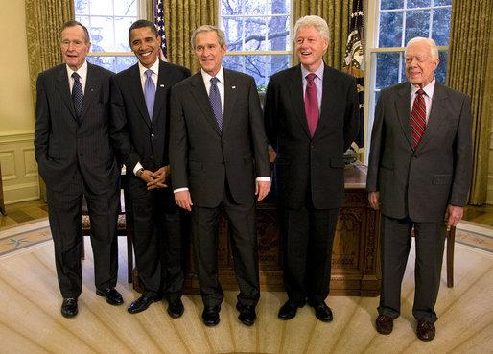  
*Four presidents and one then-president-elect. From left to right: George H. W. Bush, Barack Obama, George W. Bush, Bill Clinton, and Jimmy Carter. Photo taken in the Oval Office on January 7, 2009; Obama formally took office thirteen days later.*

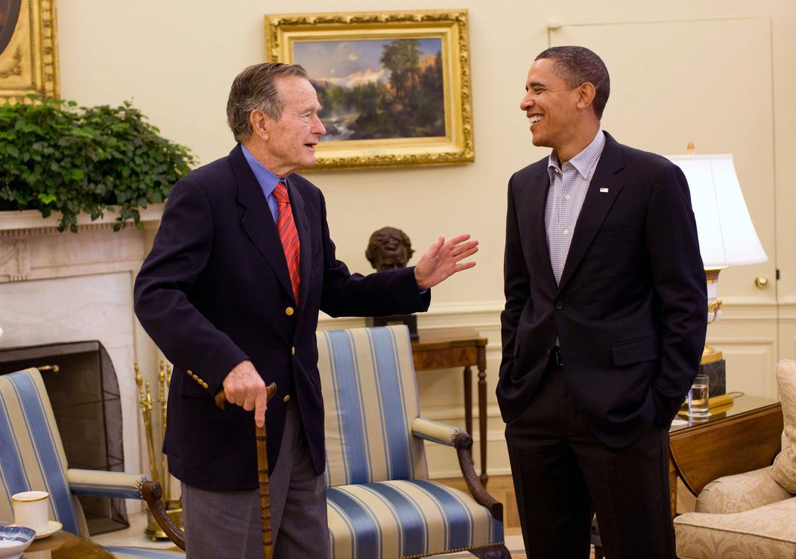  
*Bush meets President Barack Obama in the Oval Office, January 30, 2010*

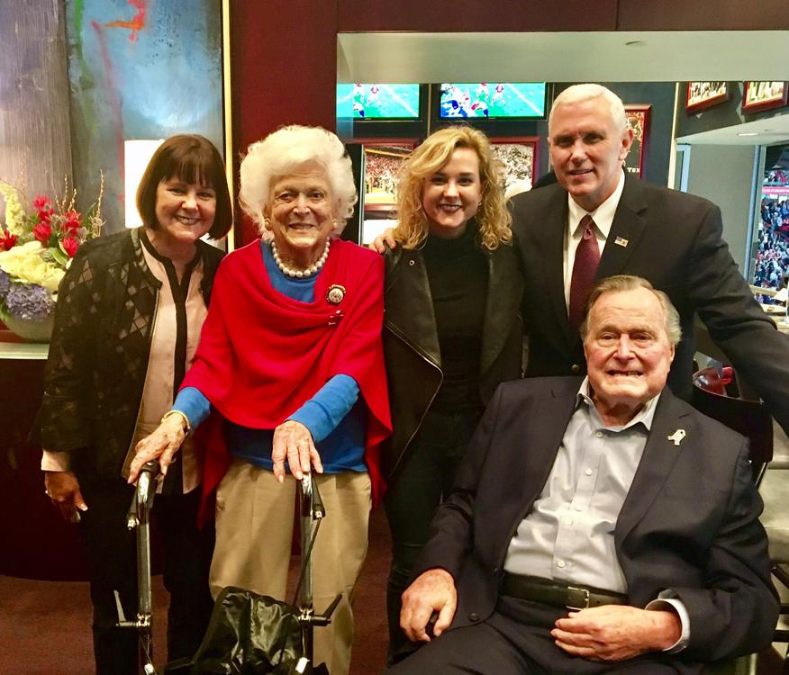  
*The Bushes with Vice President Mike Pence and family, wife Karen and daughter Charlotte, at Super Bowl LI in 2017.*

# During Obama presidency

* *The Ansary prize was presented in Houston with Ansary, Barbara Lucas, Ryan C. Crocker, dean of the Bush school since January 2010, Barbara Bush, and Curt Viebranz in attendance with the former president.*
* *Bush directed $50,000 of the prize to the Bush School of Government and Public Service at Texas A&M University, and $25,000 to fund an animation about the Siege of Yorktown for Mount Vernon.*

In October 2009, Bush joined President Barack Obama onstage at Texas A&M University for a promotion of volunteering.

On February 15, 2011, he was awarded the Presidential Medal of Freedom—the highest civilian honor in the United States—by President Barack Obama. Later that year, Bush, an avid golfer, was inducted in the World Golf Hall of Fame.

On March 29, 2012, Bush endorsed Mitt Romney for the Republican presidential nomination in the 2012 presidential election. NBC News reported that Bush had chosen to support Romney three months prior.

In July 2013, Bush had his head shaved in a show of support for the two-year-old son of a member of his security detail, who had leukemia. On July 7, Bush met with Gabrielle Giffords for part of her week-long Rights and Responsibilities Tour advocating expanded background checks in relation to firearm purchases.

In April 2014, Frederick D. McClure, chief executive of the Bush library foundation, organized a three-day gathering in College Park, Texas, to mark the 25th anniversary of the Bush administration. Also in early 2014, the John F. Kennedy Library Foundation presented the Profile in Courage Award to Bush and Mount Vernon awarded him its first Cyrus A. Ansary Prize. The Kennedy foundation award was presented by Jack Schlossberg, the late president's grandson, to Lauren Bush Lauren, who accepted on her grandfather's behalf. The Ansary prize was presented in Houston with Ansary, Barbara Lucas, Ryan C. Crocker, dean of the Bush school since January 2010, Barbara Bush, and Curt Viebranz in attendance with the former president. Bush directed $50,000 of the prize to the Bush School of Government and Public Service at Texas A&M University, and $25,000 to fund an animation about the Siege of Yorktown for Mount Vernon. Viebranz and Lucas represented Mount Vernon at the presentation.

On June 12, 2014, Bush fulfilled a long-standing promise by skydiving on his 90th birthday. He made the parachute jump from a helicopter near his home at 11:15 a.m. in Kennebunkport, Maine. The jump marked the eighth time the past president skydived, including jumps on his 80th and 85th birthday as well. He tweeted about the incident prior to the jump, saying "It's a wonderful day in Maine — in fact, nice enough for a parachute jump."

On December 7, 2016, Bush and former Senator Bob Dole commemorated the 75th anniversary of the attack on Pearl Harbor by appearing at the Bush School of Government and Public Service at Texas A&M University.

# 2016 election

* *George H. W. Bush later said that he voted for the Democratic nominee, Hillary Clinton, in the general election.*
* *nor George W. Bush endorsed the eventual Republican nominee, Donald Trump; all three Bushes emerged as frequent critics of Trump's policies and speaking style, while Trump frequently criticized George W. Bush's presidency.*
* *After Trump won the election, Bush sent him a congratulatory message.*

Bush supported his younger son Jeb's 2016 presidential bid. Jeb Bush's campaign struggled however, and he withdrew from the race during the primaries. Neither George H.W. nor George W. Bush endorsed the eventual Republican nominee, Donald Trump; all three Bushes emerged as frequent critics of Trump's policies and speaking style, while Trump frequently criticized George W. Bush's presidency. George H. W. Bush later said that he voted for the Democratic nominee, Hillary Clinton, in the general election. After Trump won the election, Bush sent him a congratulatory message.

# During Trump presidency

* *On February 5, 2017, George and Barbara Bush participated in the coin toss for Super Bowl LI.*
* *On August 16, 2017, Bush and his son George W. released a joint statement in which they condemned the violence at the Unite the Right rally.*
* *On September 7, 2017, Bush partnered with former presidents Carter, Clinton, George W. Bush, and Obama to work with One America Appeal to help the victims of Hurricane Harvey and Hurricane Irma in the Gulf Coast and Texas communities.*

On February 5, 2017, George and Barbara Bush participated in the coin toss for Super Bowl LI.

On August 16, 2017, Bush and his son George W. released a joint statement in which they condemned the violence at the Unite the Right rally.

On September 7, 2017, Bush partnered with former presidents Carter, Clinton, George W. Bush, and Obama to work with One America Appeal to help the victims of Hurricane Harvey and Hurricane Irma in the Gulf Coast and Texas communities.

# Personal life

# Faith

* *Bush replied "Good.*
* *On the day of his death, his friend James Baker told Bush that he was going to heaven.*

Bush was raised in the Episcopal Church, though by the end of his life his apparent religious beliefs are considered to have more in line with Evangelical Christian doctrine and practices. He cited various moments in his life deepening of his faith, including his escape from Japanese forces in 1944, and the death of his three-year-old daughter Robin in 1953. His faith was reflected in his Thousand Points of Light speech, his support for prayer in schools, and his support for the pro-life movement (following his election as vice president).

After his wife's death in April 2018, Bush released a statement through his spokesman, saying in part, "We have faith she is in heaven, and we know life will go on — as she would have it. So, cross the Bushes off your worry list." On the day of his death, his friend James Baker told Bush that he was going to heaven. Bush replied "Good. That's where I want to go."

# Later-life health

* *On February 24, 2000, Bush was standing at a reception for 90 minutes when he felt lightheaded.*
* *When Bush was released three days later, his doctors said that he had retained the irregularity in his heartbeat.*
* *On April 22, 2018, the day after his wife's funeral, Bush was hospitalized with a blood infection.*

In 1991, The New York Times revealed that Bush was suffering from Graves' disease, a non-contagious thyroid condition that his wife Barbara also suffered from.

On February 24, 2000, Bush was standing at a reception for 90 minutes when he felt lightheaded. He was admitted to a hospital with an irregular heartbeat. When Bush was released three days later, his doctors said that he had retained the irregularity in his heartbeat. On March 11, 2007, Bush fainted on a golf course and was admitted to the Eisenhower Medical Center in Rancho Mirage, California, but was released the following morning.

Bush suffered from vascular parkinsonism, a form of Parkinson's disease which had forced him to use a motorized scooter or wheelchair since at least 2012. Then, in July 2015, he suffered a severe neck injury. Even so, in October that year, he had recovered enough that he was able to throw out the ceremonial first pitch for the Houston Astros at Minute Maid Park. Bush wrote a letter to president-elect Donald Trump in January 2017 to inform him that because of his poor health, he would not be able to attend Trump's inauguration on January 20; he gave him his best wishes. On January 18, he was admitted to the intensive care unit at Houston Methodist Hospital, where he was sedated for a procedure to treat an acute respiratory problem that was stemming from pneumonia. Three months later, he experienced a recurrence of pneumonia and was hospitalized.

On April 22, 2018, the day after his wife's funeral, Bush was hospitalized with a blood infection. The infection led to sepsis. One month later, he was briefly hospitalized again, after experiencing fatigue and low blood pressure.

# Charity

* *In December 2018, the nonprofit Compassion International, revealed that Bush secretly sponsored a boy in the Philippines for ten years using a pseudonym.*

In December 2018, the nonprofit Compassion International, revealed that Bush secretly sponsored a boy in the Philippines for ten years using a pseudonym. He sponsored the boy from 2002 until 2012, personally writing to Timothy using the name George Walker. Timothy only found out who his sponsor had been after he graduated from the program at 17.

# Sexual misconduct allegations

* *Bush apologized for these incidents through his spokesman, Jim McGrath.*
* *In October 2017, during the Me Too movement, actress Heather Lind accused Bush of groping her and telling an inappropriate joke.*

In October 2017, during the Me Too movement, actress Heather Lind accused Bush of groping her and telling an inappropriate joke. Several other women subsequently made similar allegations. Bush apologized for these incidents through his spokesman, Jim McGrath. At the time, an editorial writer for the Washington Post noted that some would relate his behavior to his vascular parkinsonism or other senility related conditions.

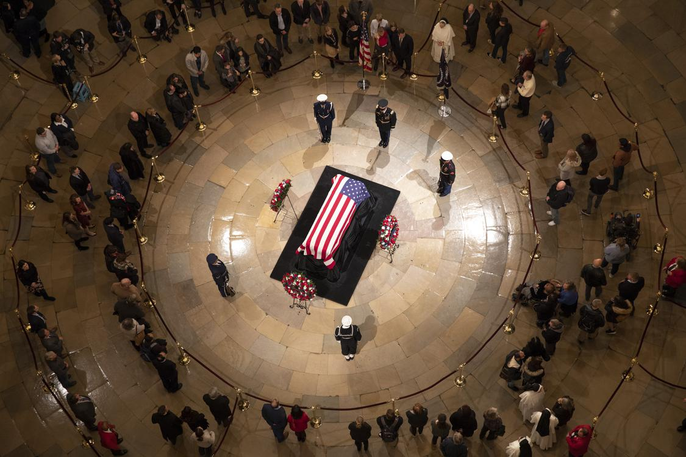  
*Members of the public pay their respects at the casket of George H. W. Bush lying in state in the Rotunda of the U.S. Capitol in Washington, D.C.*

# Death and funeral

* *George H. W. Bush died on November 30, 2018, aged 94 years, 171 days, at his home in Houston.*
* *Former president George W. Bush eulogized his father saying,*
* *Bush laid in state in the Rotunda of the U.S. Capitol from December 3 through December 5; he was the 12th U.S. president to be accorded this honor.*

George H. W. Bush died on November 30, 2018, aged 94 years, 171 days, at his home in Houston. At the time of his death he was the longest-lived U.S. president, a distinction now held (since March 22, 2019) by Jimmy Carter. He was also the third-oldest vice president.

Bush laid in state in the Rotunda of the U.S. Capitol from December 3 through December 5; he was the 12th U.S. president to be accorded this honor. Then, on December 5, Bush's casket was transferred from the Capitol rotunda to Washington National Cathedral where a state funeral was held. Former president George W. Bush eulogized his father saying,

Former Canadian prime minister Brian Mulroney (1984–1993) said,

Presidential historian Jon Meacham also gave a eulogy for the former president in which he stated, "George Herbert Walker Bush, who survived that fiery fall into the waters of the Pacific three quarters of a century ago, so that he could make our lives and the lives of nations freer, better, warmer, and nobler."

Afterward, Bush's casket was flown back to Houston and then transported to St. Martin's Episcopal Church where a second service was held on December 6. Following this his casket was brought by train to the George H.W. Bush Presidential Library in College Station, Texas where he was buried next to his wife Barbara and daughter Robin.

# Tributes

* *My thoughts and prayers are with President Bush's family and the American people."*
* *Our thoughts are with the entire Bush family tonight – and all who were inspired by George and Barbara's example."*
* *My heart goes out to the entire Bush family".*
* *Bush for over 25 years.*
* *Bush.*

Former president Barack Obama released a lengthy statement, in part it reads, "America has lost a patriot and humble servant in George Herbert Walker Bush. While our hearts are heavy today, they are also filled with gratitude. Our thoughts are with the entire Bush family tonight – and all who were inspired by George and Barbara's example."

Former First Lady Michelle Obama cancelled her book tour, saying on Twitter, "I hope readers and ticket holders will understand my decision regarding my desire to attend President Bush's funeral, and join me in paying tribute to him and his tremendous contributions to our world."

Former president Bill Clinton, in a statement described Bush's long record of service in the military, Congress, the CIA and as president, where he served from 1989 to 1993. "He never stopped serving," Clinton said. "I am profoundly grateful for every minute I spent with President Bush and will always hold our friendship as one of my life's greatest gifts."

Former Sec. of State Hillary Clinton tweeted out in remembrance of the President, "George H.W. Bush was a beloved father & grandfather, a war hero, a public servant, & a class act. In my experiences w/ him, I always valued his desire to listen, look at evidence & ask for ideas, even from people w/ different beliefs. My heart goes out to the entire Bush family".

Former president Jimmy Carter, said Bush's administration "was marked by grace, civility and social conscience." The Democrat added that through the Points of Light initiative that Bush founded, which promotes volunteerism, he embraced "a uniquely American volunteer spirit and bipartisan support."

Queen Elizabeth II released a lengthy statement saying in part, "It was with sadness that I learned of the death of President George H W Bush last night. Prince Philip and I remember our days in Texas in 1991 with great fondness. My thoughts and prayers are with President Bush's family and the American people."

German Chancellor Angela Merkel called Bush — who was U.S. president during the 1989 fall of the Berlin Wall — "one of the fathers of German reunification, and we will never forget that."  
Colin Powell in an interview with NPR, who served as chairman of the Joint Chiefs of Staff under Bush, called the former president "the most qualified president to take over that office in our history."

Ellen DeGeneres tweeted, "I will never forget George H.W. Bush and President Clinton meeting me in my old hometown of New Orleans to show support and raise money after Hurricane Katrina. I send my love to his family tonight."

At the 2018 Kennedy Center Honors, host Gloria Estefan paused the show to acknowledge the recent passing of George H.W. Bush. She also shared a personal story in which he shared his kindness to her and her son. She noted that Bush was a "wonderful man who dedicated his life to service and who graciously attended this event many times during his administration". The entire theatre applauded and in tribute to Bush gave him a standing ovation.

On Saturday Night Live, during the Weekend Update segment, Colin Jost and Michael Che paid tribute to the late president saying, "President Bush was famously a warm and gracious man who always understood the power of being able to laugh at yourself", before cutting to a clip package of Dana Carvey's legandary and iconic impersonation of the President. Following Bush Sr's death Carvey released a statement remembering the President saying, ""It was an honor and a privileged to know and spend time with George H.W. Bush for over 25 years. When I think of those times what I remember most is how hard we would laugh. I will miss my friend."

On the Late Show with Stephen Colbert, Colbert honored "the last president from the greatest generation" saying, "The 41st President was known for the kindness and respect he showed to even his political rivals...we may never see the likes of that again" Later Colbert asked Sen. Bernie Sanders, who was on the show about the passing of Bush Sr., to which Sanders replied "Of course I disagreed with him [H.W. Bush], but he was an honest man, he was a decent man, he loved his country very much...we wish that we could have a president who was honest back in the White House again"

# Legacy

* *Years later, Bush would receive a Profile in Courage Award from John F. Kennedy's grandson who said America's gain was President Bush's loss.*
* *While Reagan had been the first modern president to do so in 1989, Bush's move was significant in that his gesture of goodwill was made towards Clinton, the man to whom Bush had just lost the election.*

Polls of historians and political scientists have ranked Bush in the top half of presidents. A 2018 poll of the American Political Science Association's Presidents and Executive Politics section ranked Bush as the 17th best president out of 44. A 2017 C-Span poll of historians also ranked Bush as the 20th best president out of 43.

Upon his death many in the news media remembered his 1988 speech when receiving his party's nomination for president, he declared that he wanted "a kinder, gentler nation," adding, "We are a nation of communities, of thousands, and tens of thousands, of ethnic, religious, social, business, labor union, neighborhood, regional, and other organizations, all of them varied, voluntary and unique ... a brilliant diversity spread like stars, like a thousand points of light in a broad and peaceful sky.".

Scott Horsley of NPR, wrote "The 41st president of the United States led the country through turbulent times, including the end of the Cold War and the first Gulf War. His life exemplified service to his country". and that "The tax hike cut the deficit, but it cost Bush dearly with conservatives. Years later, Bush would receive a Profile in Courage Award from John F. Kennedy's grandson who said America's gain was President Bush's loss. Bush's most notable accomplishments in the White House came in the area of foreign policy. While Ronald Reagan is often credited with winning the Cold War, biographer Naftali says it was Bush who successfully navigated the aftermath. His low-key approach avoided inflaming communist hard-liners and allowed for the peaceful breakup of the Soviet Union."

On the PBS NewsHour Weekend, they credited him with "bringing the Cold War to a peaceful end after the fall of the Berlin Wall, and signed the American with Disabilities and Clean Air acts into law."

Presidential historian Jon Meacham described Bush's life as one of "great privilege but who believed and embodied the idea that to whom much is given, much is expected". He also noted his "grace, civility, and prudence"

On MSNBC he was called the "last gentleman in Washington", who chose the path of "conviction over convenience" They also noted despite his extraordinary legacy, the divisive Clarence Thomas hearings that happened during his presidency as well as President Reagan's poor response to the AIDS crisis.

President Obama commented on Bush's legacy by crediting him with "expanding America's promise to new immigrants and people with disabilities. Reducing the scourge of nuclear weapons and building a broad international coalition to expel a dictator from Kuwait. And when democratic revolutions bloomed across Eastern Europe, it was his steady, diplomatic hand that made possible an achievement once thought anything but - ending the Cold War without firing a shot, It's a legacy of service that may never be matched, even though he'd want all of us to try."

According to presidential historian Mark K. Updegrove, Bush "cemented" the tradition of presidents leaving behind letters of support for their successors on the Resolute Desk. While Reagan had been the first modern president to do so in 1989, Bush's move was significant in that his gesture of goodwill was made towards Clinton, the man to whom Bush had just lost the election. President Clinton spoke with 60 Minutes in a part of a tribute to Bush Sr., commenting on the letter saying, "This letter is a statement of who he is. That's why he's a world-class human being in my book. ... And our friendship just got better. And in a world where everybody's just gutting each other all the time I thought it was a good thing to show. ... It's been one of the great joys of my life, my friendship with him. Our arguments were good-natured and open, and — we continue to debate things all the way up until recently."

According to USA Today, the legacy of Bush's presidency was defined by his victory over Iraq after the invasion of Kuwait, and for his presiding over the collapse of the USSR and unification of Germany. The paper said his political legacy would "continue years later through his son, George W. Bush, who became the 43rd president of the United States."

# Presidential library

* *Bush Presidential Library is the nation's tenth presidential library which was built between 1995 and 1997.*
* *The George H.W.*
* *It contains the presidential and vice presidential papers of Bush and the vice presidential papers of Dan Quayle.*
* *The Bush School of Government and Public Service is a graduate public policy school at Texas A&M University in College Station, Texas, which was established in 1995.*

The George H.W. Bush Presidential Library is the nation's tenth presidential library which was built between 1995 and 1997. It contains the presidential and vice presidential papers of Bush and the vice presidential papers of Dan Quayle. It was dedicated on November 6, 1997, and opened to the public shortly thereafter; the architectural firm of Hellmuth, Obata and Kassabaum designed the complex.

The George H.W. Bush Presidential Library is located on a 90-acre (36 ha) site on the west campus of Texas A&M University in College Station, Texas, on a plaza adjoining the Presidential Conference Center and the Texas A&M Academic Center. The Library operates under NARA's administration and the provisions of the Presidential Libraries Act of 1955.

The Bush School of Government and Public Service is a graduate public policy school at Texas A&M University in College Station, Texas, which was established in 1995. The graduate school is part of the presidential library complex, and offers four programs — two master's degree programs (Public Service and Administration, and International Affairs) and three certificate programs (Advanced International Affairs, Nonprofit Management, and Homeland Security).

# See also

* *Electoral history of George H. W. Bush*

Electoral history of George H. W. Bush

List of Presidents of the United States by previous experience

List of Presidents of the United States

# Notes

# References

# Further reading

# Primary sources

* *Bush, George H. W. (1987).*
* *Bush, George H. W. (2011).*
* *Bush, George H. W.; Scowcroft, Brent (1998).*
* *"Interview with: George W. Bush, Barbara Bush" (Interview).*
* *Bush, George H. W. (1999).*
* *Bush, George H. W.; Bush, Barbara (2009).*
* *Bush, George W. (2014).*

Bush, George H. W. (1987). Looking Forward: An Autobiography. New York: Doubleday. ISBN 978-0-385-14181-9.

Bush, George H. W.; Scowcroft, Brent (1998). A World Transformed. New York: Knopf. ISBN 978-0-679-43248-7.

Bush, George H. W. (1999). All the Best, George Bush: My Life in Letters and Other Writings. New York: Scribner. ISBN 978-0-684-83958-5.

Bush, George H. W.; Bush, Barbara (2009). "Interview with: George W. Bush, Barbara Bush" (Interview). Interviewed by McGrath, Jim. Retrieved October 8, 2014.

Bush, George W. (2014). 41: A Portrait of My Father. Crown. ISBN 978-0-553-44778-1.

Bush Koch, Dorothy (2006). My Father, My President: A Personal Account of the Life of George H. W. Bush. Grand Central Publishing. ISBN 978-0-446-57990-2.

Bush, George H. W. (2011). Engel, Jeffrey A. (ed.). The China Diary of George H. W. Bush: The Making of a Global President. Princeton UP. ISBN 978-1-4008-2961-3.

# External links

* *"George H. W. Bush (id: B001166)".*
* *George H. W. Bush an American Experience documentary*
* *Bush Presidential Library Center*
* *Appearances on C-SPAN  
  "Life Portrait of George H. W. Bush", from C-SPAN's American Presidents: Life Portraits, December 13, 1999*
* *"George H. W. Bush collected news and commentary".*
* *George H.W.*

George H.W. Bush Presidential Library Center

White House biography

Full audio of a number of Bush speeches Miller Center of Public Affairs

"George H. W. Bush collected news and commentary". The New York Times.

United States Congress. "George H. W. Bush (id: B001166)". Biographical Directory of the United States Congress.

Extensive essays on Bush and shorter essays on each member of his cabinet and First Lady from the Miller Center of Public Affairs

Appearances on C-SPAN  
"Life Portrait of George H. W. Bush", from C-SPAN's American Presidents: Life Portraits, December 13, 1999

George H. W. Bush an American Experience documentary